Texas Department of Agriculture
Request for Proposal –Texas Rural Internship Program

Overview

The Texas Department of Agriculture (TDA) is inviting proposals from rural communities for the Texas Rural Internship Program. The purpose of the program is to provide urban college students (those with a classification of at least a junior) an opportunity to experience life in a rural Texas community during the summer.
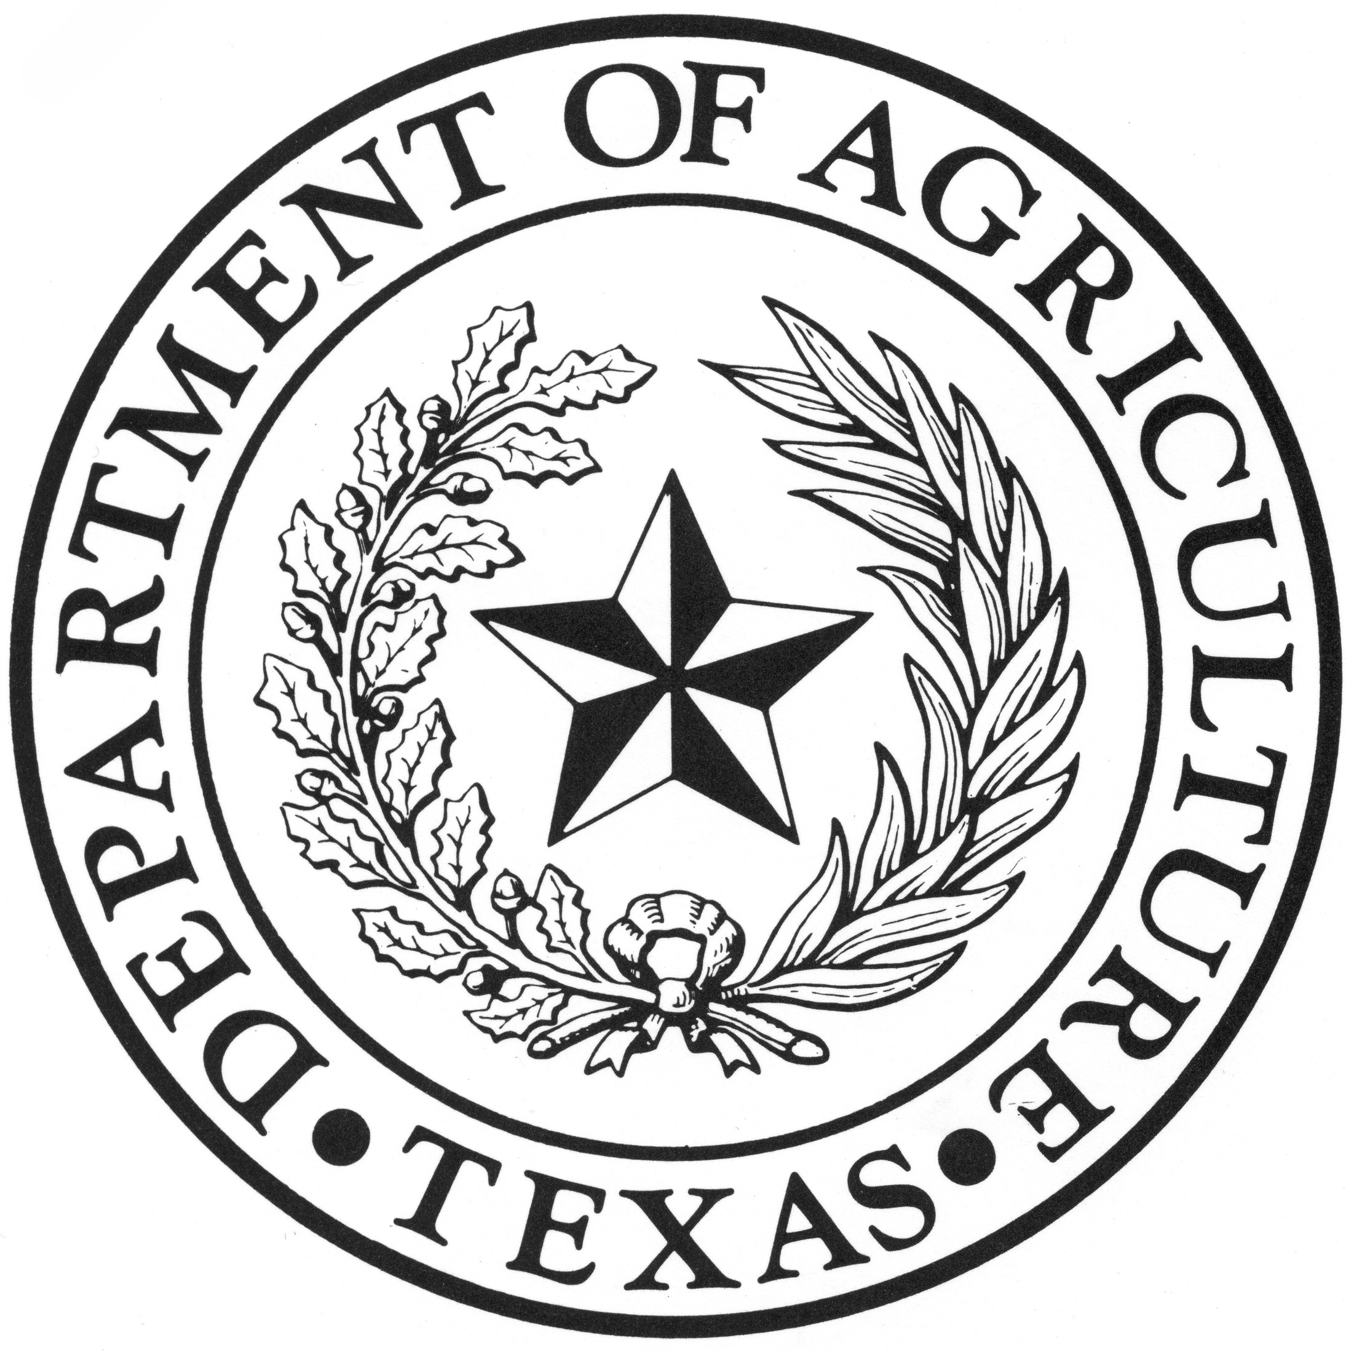
The Center for Rural Studies at Sam Houston State University and Texas Tech University will assist with actively seeking student participants. TDA will act as a clearinghouse for the selection of host communities and potential interns. The internship is designed to last five to ten weeks, 1 or 2 summer sessions. These dates are negotiable based on the schedule of the student intern and the host community.

Benefits to the Community

Participating communities have benefitted from this program with a new perspective and talent from an intern. Much of this talent includes updated technical skills, fresh computer skills, and a working knowledge of social networking.

In previous years, interns performed a variety of tasks and projects benefiting the host community.

Our experience has shown that paid internships provide a more qualified field of candidates. As a result, a stipend of $1,000 will be required of the participating communities. This amount may vary depending on the length of the internship.

Students will be required to provide transportation, a valid Texas driver’s license, and proof of medical insurance.

Desired Outcomes

The purpose of the Texas Rural Internship Program is to provide a unique, educational and productive summer internship that will be mutually beneficial for the student and the community. Community participation in this program will ideally produce the following results:

- introduce urban students to rural Texas communities;
- provide a unique opportunity for rural Texas communities to host a student and showcase their community;
- promote rural Texas to attract and retain a work force; and
- encourage student interns to:
  - move to the rural community upon graduation;
  - become an ambassador for rural Texas; and
  - pursue entrepreneurial opportunities in rural Texas.

Application

Communities must submit a proposal on the attached form provided by TDA. In the proposal, communities will outline the work experience or project that would be assigned to a student intern. Communities will also provide details on room and board for the student, community service opportunities, opportunities for the student to gain knowledge about government and non-government organizations and unique regional opportunities.

Proposals should be submitted to:

Texas Department of Agriculture
Office of Rural Affairs
ATTN: Rick Rhodes
P.O. Box 12847
1700 N. Congress Avenue, 11th Floor
Austin, TX 78711

Proposals must be received no later than 5:00 p.m. on February 17, 2014.

Contact Information

If you have questions, please contact Rick Rhodes at rick.rhodes@texasagriculture.gov or 512.463.7577.

Reporting Requirements

Project Coordinators will be required to submit a Final Activity Report of the results of the program. Report narrative, including photographs to document such results, will be due within thirty (30) days of program completion.

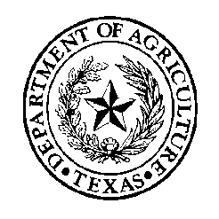
Texas Department of Agriculture
Todd Staples, Commissioner

Susan Combs, Commissioner

Request for Proposals
Texas Rural Internship Program

Host City |  | County
Contact Person
Mr. Mrs.  Ms. Other____ | First Name | M. I. | Last Name | Sr.  Jr.
Title |  | Organization
Phone Number |  | E-mail Address

Project details
In order to ensure a quality internship for both the community and the student, as well as match an intern’s skill set with a community’s need, please provide a detailed description. Please include job responsibility, specific skills needed or desired and any additional information that will assist TDA in its review of your proposal.

Students may be interested in taking online courses, during their internship. Does your community have access to broadband service, sufficient to support on-line training and educational courses? |  |  | Y N
- The community will be responsible for providing room and board for the student intern at no charge. Preferably, the student will live with a host family. Please describe with as much detail as possible where the student will be living during the internship and how meals will be provided.

- An additional component of the internship is community service. What opportunities exist within your city for community service? Examples: United Way, Red Cross, Meals on Wheels, Little League, hospital volunteer, etc. Please explain how the student will be involved.

- What opportunities exist within your community for the student to gain exposure to governmental and non-governmental organizations? Examples: study city government, meet local elected officials, meet state representatives, military, low-income housing, Texas Workforce Commission, etc.

- Please describe any unique regional opportunities for a student within your community. Examples: day trips, tourist attractions, local festivals, unique sightseeing, etc.

- Please indicate your preference for one or two students. |  | One Two
- Which session would your community prefer?
  - Session One (May 29-June 26, 2014) Session Two (July 2-July 31, 2014)
  - Either Session Both
- What other miscellaneous opportunities does your community offer for the student? e.g., taking summer courses, meeting young hosts (recent college graduates), spending an hour a week with a mentor, etc.

10. Please provide any additional information you believe would be beneficial.

Signature of responsible party required
________________________________________________ _____________________________
Signature Date
Please mail the completed RFP to:  Texas Department of Agriculture  Office of Rural Affairs  P.O. Box 12847  Austin, Texas 78711 | For questions, please contact:  Rick Rhodes  rick.rhodes@texasagriculture.gov  (512) 463-7577

