CHAPTER 3

ENVIRONMENTAL REVIEW

TABLE OF CONTENTS

Page

3.0 Introduction 2
3.0.1 Basis of Environmental Review 3
3.0.2 Timing of the Environmental Review and Choice-limiting Actions 3
3.1 Environmental Review Process 4
3.1.1 Step 1. Determine Project Description 4
3.1.2 Step 2. Determine the Level of Review 5
3.1.3 Step 3. Complete Checklists 8
Historic Preservation Requirements 9
8-Step Process for Floodplain Management and Protection of Wetlands 10
Tiered Review 13
Environmental Impact Statement 14
3.1.4 Step 4. Publish Notices 14
3.1.5 Step 5. Certifications 15
3.1.6 Step 6. Submit Clearance Documentation to TDA 17
3.1.7 Step 7. State Objection Period and Release of Funds 17
3.1.8 Step 8. State’s Post-Release Review 18
3.1.9 Step 9. Re-Evaluation of the Environmental Determination and Subsequent Amendment/Modification Procedure 18
3.2 Environmental Laws and Regulations 20
3.2.1 Laws 20
NEPA 20
Executive Order 11514 20
Executive Order 11991 20
Historic Preservation Requirements: 20
3.2.2 Regulations 21

CHAPTER 3

ENVIRONMENTAL REVIEW

3.0 Introduction

The TxCDBG Grant Recipient is responsible for compliance with federal environmental review requirements. This chapter includes a summary and basic understanding of the process. Any periodic updates provided by HUD environmental compliance staff will be required for Grant Recipients, and personnel completing the environmental review should be familiar with the resources and forms found on the HUD Environmental Review website, also known as HUD Exchange, and should contact the TDA Environmental Specialist at CDBG_EnvReview@TexasAgriculture.gov for technical assistance.

HUD guidance uses the term Responsible Entity (RE) to refer to the unit of government responsible for meeting environmental review requirements—the Grant Recipient is the RE for all TxCDBG projects. This means that the Grant Recipient is responsible for completing the review, with or without assistance from a third party, and certifying the results. When the certifying officer signs the documents, (s)he certifies that not only has the project been found to have, or not have, significant impacts on the environment, but also that the required process was completed to reach this finding.

The certifying officer is the chief elected official, chief executive official, or other official designated by formal resolution of the governing body authorizing the signatories either by job title or name. The certifying officer must have the authority to assume legal responsibility for certifying that all environmental requirements have been followed. This function may not be assumed by administering agencies or consultants. The local governing body may appoint an alternate official to serve as the certifying officer with the understanding that either the primary or alternate will assume the same administrative and legal responsibilities described in 24 CFR §58.13. Either official authorized by the local government may approve environmental actions or execute required environmental forms on TDA-GO.

BEST PRACTICE: The Grant Recipient’s chief elected official (mayor or county judge) signs the environmental review documentation.

TDA will monitor the Grant Recipient’s compliance with HUD environmental review requirements; failure to comply with these requirements will jeopardize the project and could lead to disallowed costs, repayment of funds, and suspension from the program for the Grant Recipient and administrators involved with the environmental review process.

Send all technical assistance emails to the Environmental Specialist at CDBG_EnvReview@TexasAgriculture.gov.

For specific HUD environmental regulations, see 24 CFR part 58.

3.0.1 Basis of Environmental Review

A key concept in performing an environmental review is to consider the impact of proposed project activities on the prospective project site(s). Likewise, an environmental review must assess any potential adverse impact that the environment in a planned site location may have on the project itself. HUD regulations require a Grant Recipient to group together and evaluate as a single review all individual activities which are related either on a geographical or functional basis or are logical parts of a composite of contemplated actions. EXAMPLE: If TxCDBG funds are being used to acquire a site for a new construction project, the ultimate effect of the project is not solely the acquisition of the site, but also the construction of the project, including the installation of any associated infrastructure. Therefore, the environmental review must address the impacts of both the TxCDBG-funded land acquisition and the privately financed construction of the project. The review must address the actual project site and the surrounding area.

The basics of an environmental review include, but are not limited to the following questions:
- What is there currently?
- What will be there once the project is completed?
- How will this be accomplished?

3.0.2 Timing of the Environmental Review and Choice-limiting Actions

An environmental review must be performed before any construction funds—regardless of source—are committed to an activity or a project. No activity or project may be undertaken if the activity or project would have an adverse environmental impact or limit the choice of reasonable alternatives. See 24 CFR §58.22(a). This prohibition on “choice-limiting actions” prohibits physical activity—including acquisition, rehabilitation, and construction—as well as contracting for, or committing to any of these actions.

Therefore, Grant Recipients are required to complete their environmental reviews, Requests for Release of Funds, and clearance-related paperwork before
- any commitment of TxCDBG funds for activities not including administration/engineering; and
- any commitment of non-TxCDBG funds or before undertaking activities that would have an adverse environmental impact or limit the choice of alternatives.

SPECIAL CASE: Project in Progress – A party may begin a project in good faith as a private project and is not precluded from later deciding to apply for federal assistance. If the choice-limiting action was undertaken prior to the resolution authorizing submittal of the TxCDBG application, the activity that was started is not required to be suspended. However, when a unit of local government applies for CDBG funding, it must cease further choice-limiting actions, including additional commitment of funds, on the project until the environmental review process is complete. Please contact TDA at CDBG_EnvReview@TexasAgriculture.gov if the preceding applies to your project.

SPECIAL CASE: Option Contract – A contract to purchase or lease property for a TxCDBG project before the environmental review is completed is considered a commitment of funds and a choice-limiting action according to 24 CFR §58.22(a) and must be avoided until after the environmental review process is completed and TDA has issued a release of funds. See Chapter 6 Acquisition of Real Property for details on acceptable option contracts.

3.1 Environmental Review Process

Under 24 CFR Section 58.30(b), the environmental review process should begin as soon as the Grant Recipient determines the projected use of HUD assistance. TDA considers the earliest determination of “the projected use of HUD assistance” as noted in 24 CFR §58.30 to adoption of the resolution authorizing submission of the grant application, or a similar formal action taken by the Grant Recipient (Responsible Entity) to prepare for or file an application directly with TDA for TxCDBG funding.

The Environmental Review Performance Report form is created automatically in TDA-GO during the funding process and can be found in the Related Documents section of the navigation menu.

From the Home page, select the gray Forms drop-down field. Next, select the Environmental Review Main Form which is located under the Performance Report subsection of the Forms drop-down field.

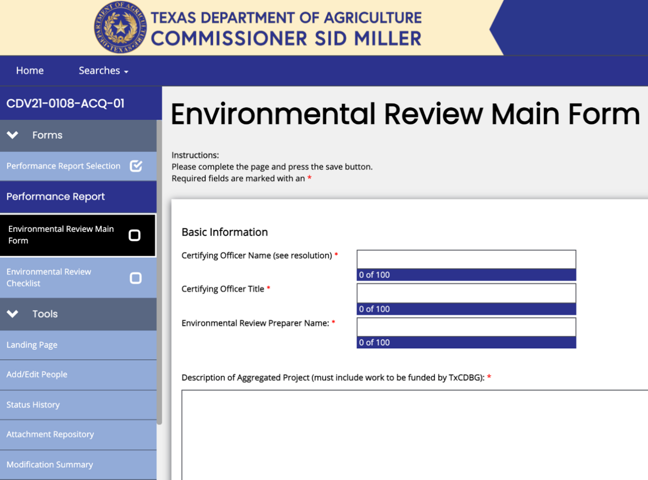

Figure 1. Environmental Review Main Form page

3.1.1 Step 1. Determine Project Description

A complete and clear project description is the first step in the environmental review process. The project description should provide location-specific information and geographic boundaries, a delineation of all activities included in the overall scope of the project as well as a description of the existing conditions of the site. This should include specific addresses where the work will be performed even if the grant agreement Performance Statement does not provide this level of detail. However, all elements described in the TxCDBG grant agreement Performance Statement (Exhibit A) must be included in the description. In addition, any activities not funded by the TxCDBG but are part of the aggregate impact of the project on the environment must also be included in the description and in the environmental assessment, including any business attached to a CDBG project. This description is the foundation for the review process and must be listed on the Environmental Review Record Summary Sheet.

BEST PRACTICE: Include in the project description alternative construction activities and locations where additional work may be completed if budgeted project funds allow. These activities and locations must be included in the scope of the environmental review study.

Grant Recipients must complete an environmental review for each project, including all functionally-related and geographically-related activities, and the associated administration and engineering work.
- Professional and Related Services – Executing a service grant agreement for administration or engineering work necessary to complete the project is not considered a “choice-limiting action” and does not violate 24 CFR §58.22. Therefore, it is not necessary to file an exemption for administration and engineering services separate from the environmental review for the related activity. However, these activities must be included in the project description contained in the environmental review record and must also be included in scope of project activities listed in the published finding of no significant impact and/or notice of intent to request release of funds.
- Projects in a Floodway – Infrastructure projects in areas mapped as “floodways” may only be funded if
  - the infrastructure is installed below the floodway using directional drilling below ground level; any potential erosion issues will be addressed in the 8-Step Process (see below); or
  - the infrastructure is elevated above the floodway and installed above the base flood level, such as pipelines mounted to existing bridges above the base flood mark.
  - no housing or other structures “not functionally dependent” on the waterway will be funded if located within the floodway itself.
  - For additional guidance, see also HUD’s Notice CPD-17-013, “Notice for Interpreting the Limits of the Floodway for Linear Infrastructure Projects Complying with HUD Floodplain Management Regulations, 24 CFR Part 55.”
- Projects in a Floodplain – Grant Recipients completing projects in a floodplain must complete the 8-Step Process and participate in the National Flood Insurance Program (NFIP). The Grant Recipient must maintain documentation with the Environmental Review Record (ERR) of participation in the NFIP. This information can be obtained at https://www.fema.gov/flood-insurance/work-with-nfip/community-status-book website.

3.1.2 Step 2. Determine the Level of Review

The Grant Recipient must determine the most appropriate level of review for the TxCDBG funded project. See Summary of Levels of Environmental Review and Documentation Required in ERR (Form A309). It is critical that the project receive an adequate review to meet statutory requirements; however, it is not appropriate to require reviews that exceed the statutory guidance.

For information regarding level of review for environmental, please refer to the HUD’s resources and guides on environmental review located on the HUD Exchange.

The Grant Recipient should determine the most appropriate level of review, which TDA will confirm or require to be adjusted as the review process progresses. Three regulations identify activities that fall under review levels less than the Environmental Assessment. See also Summary of Levels of Environmental Review and Documentation Required in ERR (Form A309).

- 24 CFR §58.34: Exemption
Certain activities are, by their nature, highly unlikely to have any direct impact on the environment. Accordingly, these activities are not subject to most of the procedural requirements of environmental review. Listed below are examples which may qualify for an Exempt Level Environmental Review. For complete details refer to the environmental regulations.
  - Environmental and other studies;
  - Information and financial services;
  - Administrative and management activities;
  - Engineering and design costs;
  - Interim assistance (emergency) activities if the assisted activities do not alter environmental conditions and are for temporary or permanent improvements limited to protection, repair or restoration actions necessary only to control or arrest the effects of disasters or imminent threats to public safety or those resulting from physical deterioration;
  - Public service activities that will not have a physical impact or result in any physical changes;
  - Inspections and testing of properties for hazards or defects;
  - Purchase of tools or insurance;
  - Technical assistance or training;
  - Payment of principal and interest on loans made or guaranteed by HUD; and
  - Any of the categorically excluded activities subject to Section 58.5 as listed in 58.35(a), provided there are no circumstances which require compliance with any other Federal laws and authorities listed in Section 58.5 of the regulations. For instance, projects located in one of the following areas cannot qualify for conversion to the Exempt level of review:
    - A floodplain (for structures that include walls and a roof);
    - A known critical habitat for endangered species;
    - A historic property; or
    - A known hazardous site.

2. 24 CFR §58.35(b) Categorically Excluded, Not Subject To §58.5 (CENST)
The following activities, listed at 24 CFR Section 58.35(b), have been determined to be categorically excluded in accordance with National Environmental Policy Act (NEPA) requirements and are not subject to 24 CFR §58.5 compliance determinations:
  - Tenant-based rental assistance;
  - Supportive services including but not limited to health care, housing services, permanent housing placement, short-term payments for rent/mortgage/utility costs, and assistance in gaining access to local, state, and federal government services;
  - Operating costs including maintenance, security, operation, utilities, furnishings, equipment, supplies, staff training, recruitment, and other incidental costs;
  - Economic development activities including, but not limited to, equipment purchase, inventory financing, interest subsidy, operating expenses, and similar costs not associated with construction or expansion of existing operations;
  - Activities to assist homebuyers to purchase existing dwelling units or dwelling units under construction such as closing costs, down payment assistance, interest buy downs and similar activities that result in the transfer of title to a property; and
  - Affordable housing predevelopment costs with NO physical impact such as legal, consulting, developer and other costs related to obtaining site options, project financing, administrative costs and fees for loan commitments, zoning approvals, and other related activities which do not have a physical impact.

The Grant Recipient must determine whether the activity triggers any of the other requirements at 24 CFR § 58.6, which are: the Flood Disaster Protection Act; the Coastal Barriers Resources Act; and HUD’s requirement for disclosure of properties located in airport runway clear zones.

- 24 CFR §58.35(a) Categorically Excluded, Subject To §58.5 (CEST)
The list of categorically excluded activities is found in 24 CFR Section 58.35. While the activities listed in §58.35(a) are categorically excluded from NEPA requirements, the RE must nevertheless demonstrate compliance with the laws, authorities, and Executive Orders listed in 24 CFR §58.5.

The following are categorically excluded activities subject to §58.5:
  - Acquisition, repair, improvement, reconstruction, or rehabilitation of public facilities and improvements (other than buildings) when the facilities and improvements are in place and will be retained in the same use without change in size, or capacity of more than 20%.
  - Special projects directed toward the removal of material and architectural barriers that restrict the mobility of and accessibility to elderly and disabled persons.
  - Rehabilitation of buildings and improvements when the following conditions are met:
    - For residential properties with one to four units:
      - The density is not increased beyond four units;
      - The land use is not changed; and
      - If the building is located in a floodplain or in a wetland, the footprint of the building is not increased.
    - For multi-family residential buildings (with more than four units):
      - Unit density is not changed more than 20%;
      - The project does not involve changes in land use from residential to non-residential; and
      - The estimated cost of rehabilitation is less than 75% of the total estimated replacement cost after rehabilitation.
    - For non-residential structures including commercial, industrial and public buildings:
      - The facilities and improvements are in place and will not be changed in size or capacity by more than 20%; and
      - The activity does not involve a change in land use, e.g. from commercial to industrial, from non-residential to residential, or from one industrial use to another.
  - An individual action on up to four-family dwelling where there is a maximum of four units on any one site. Individual action refers to new construction, development, demolition, acquisition, disposition or refinancing (does not include rehabilitation which is covered previously). The units can be four one-unit buildings or one four-unit building or any combination in-between;
  - An individual action on a project of five or more housing units developed on scattered sites when the sites are more than 2,000 feet apart and there are not more than four housing units on any one site;
  - Acquisition (including leasing) or disposition of or equity loans on an existing structure, or acquisition (including leasing) of vacant land provided that the structure or land acquired, financed, or disposed of will be retained for the same use.
  - Combinations of the above activities.

Categorical Exclusion Converted to Exemption 24 CFR §§58.34(a)(12) and 58.35(a) HUD regulations at §58.34(a)(12) permit some projects to convert from a Categorically Excluded project to Exempt status. The Grant Recipient must first carefully determine that none of the statutory requirements under Section 58.5 apply to the project. Using the Categorical Exclusion Subject to §58.5 (Form A304), the Grant Recipient will determine if the project it is preparing to undertake can be converted to exempt under Section 58.34(a)(12).

- Environmental Assessment (EA)
Activities which are neither exempt nor categorically excluded under each category will require an Environmental Assessment (Form A302) documenting compliance with NEPA, HUD, and with the environmental requirements of other applicable Federal laws.

3.1.3 Step 3. Complete Checklists

The HUD Exchange includes various checklists intended to help the Grant Recipient address all issues and regulations for HUD environmental review requirements. These checklists have been incorporated into the TDA-GO Environmental Review Performance Report as separate pages that become available based on the information provided in the report. For each of these checklists, the Grant Recipient must respond to each element with information from a verifiable source, to be included in the Environmental Review Record.

From the Forms drop-down field of the grant application, select the Environmental Review Checklist located under the Performance Report subsection. Using the Environmental Review page in TDA-GO select the appropriate level of review to generate the required checklist. These checklists and the supporting documentation form the Environmental Review Record (ERR).

NOTE: Changing the level of review will result in the loss of any data previously associated with the existing level of review. This loss of data will occur once the page is saved and cannot be reversed.

Downloadable copies of the required checklists, guidance, and a more detailed explanation of laws and regulations most commonly applicable to TxCDBG projects can be found on the Environmental Review webpage in the HUD Exchange.

Documentation of compliance with these laws must be included in the ERR. If the project will affect or be affected by any of these laws and authorities, the Grant Recipient should initiate consultation with the appropriate regulatory agency. All written correspondence should reference the TxCDBG grant agreement number. Photos of the project site must be included in the ERR to document the project site visit required by several checklist items. These can be uploaded directly to the TDA-GO Environmental Review Checklist. See Figure 2.

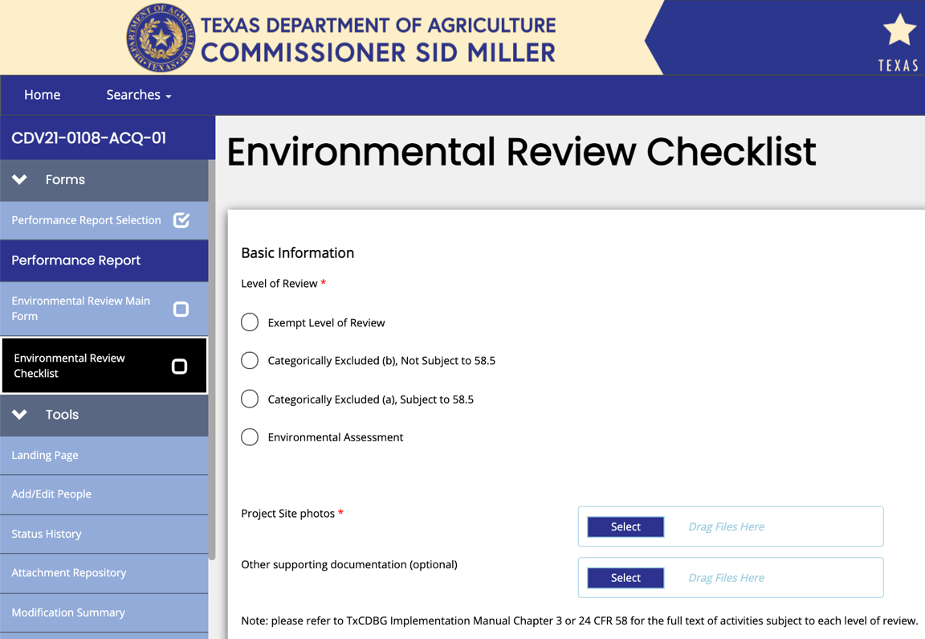

Figure 2. Environmental Checklist page in TDA-GO

Additional Guidance for Certain Review Requirements

Historic Preservation Requirements
As part of the Statutory Checklist, under Categorical Exclusion 24 CFR §58.35(a) and Environmental Assessment projects, each Grant Recipient/Applicant must have concurrence from the State Historic Preservation Officer (SHPO) that the project will not adversely affect historically or archaeologically significant areas or structures. The SHPO in Texas is the Commissioner of the Texas Historical Commission. TDA has entered into a Programmatic Agreement with the Texas Historical Commission (THC) which under very specific conditions may allow for an exception to the requirement for SHPO clearance.
- Grant Recipients/Applicants meeting certain criteria may satisfy the Historical Preservation requirements by certifying the Request for Exemption from SHPO Review on the Section 106 page of the Environmental Review Performance Report. If the project does not meet the criteria outlined in the Programmatic Agreement, or if the Grant Recipient/Applicant does not provide an adequate project description or other information needed to determine compliance, TDA will not approve the exemption. TDA’s determination of a responsible entity’s Section 106 exemption request is at the sole discretion of the department and considered final.
- If the project does not have an exemption from SHPO Review approved by TDA, the Grant Recipient must submit to the SHPO a Historic Preservation Notice and allow at least 35 calendar days for the SHPO to review. Once TDA has denied approval of a request for a SHPO exemption, subsequent requests for SHPO approval for the same project must be submitted directly to the Texas Historical Commission (THC). A copy of the Historic Preservation Notice and response must be kept in the Environmental Review Record.
- A project that does not have a Section 106 exemption approval must also consult with the Tribal Historic Preservation Officer (THPO) for each tribe that has declared an interest in the area. The relevant tribal contacts for each county can be found in HUD’s Tribal Directory Assistance Tool, click the Generate Tribal Consultations letter in TDA-GO to prepare the required government-to-government consultation letters for the identified tribes. As a best practice, Grant Recipients should send consultation letters and emails directly to the THPO. Consultants/Environmental Review Preparers may email consultation letters to the THPO on behalf of the Grant Recipient – the email must include the Grant Recipient certifying officer as a cc recipient and must identify the sender as a third party assisting the local government with administrative tasks for government-to-government consultation. Allow a minimum of 30 calendar days for a response to consultation letters sent electronically, and 35 days for consultation letters sent by certified mail. Copies of these letters, responses, and evidence of delivery to the tribal contacts (email delivery or certified mail) must be retained in the Environmental Review Record.

8-Step Process for Floodplain Management and Protection of Wetlands
Except for actions covered by 24 CFR §55.12(a), eight steps are required to make decisions for a project proposed to occur in a floodplain or wetland, including public notices and an examination of practicable alternatives. This process must be documented on the Part 55 page of the Environmental Review Performance Report.

The steps to be followed in the decision-making process are found in 24 CFR Part 55 - Subsection C as follows:

Step 1. Floodplain/Wetlands
Determine whether the proposed TxCDBG funded project is located in the following:
- 100-year floodplain;
- 500-year floodplain for critical actions; or
- results in new construction in a wetland.

A critical action means any activity for which even a slight chance of flooding might be too great because such flooding might result in a loss of life, injury to persons, or damage to property. Critical actions include activities that create, maintain, or extend the useful life of those structures or facilities that are likely to contain occupants who may not be sufficiently mobile to avoid loss of life or injury during flood or storm events, such as hospitals or residential care facilities. See HUD Floodplain Management.

To determine whether a wetland exists, refer to 24 CFR §55.2(b)(11):

If the action does not occur in a floodplain or result in new construction in a wetland, then no further compliance with this part is required. This determination is recorded on the TDA-GO environmental review page.

Step 2. Floodplain/Wetlands
Notify the public and agencies responsible for floodplain management or wetlands protection at the earliest possible time of a proposal to consider an action in a 100-year floodplain (or a 500-year floodplain for a Critical Action) or wetland. Engage the affected and interested public and agencies in the decision-making process.
- The public notices required may be combined with other project notices wherever appropriate. Notices required under this part are considered vital documents under the Grant Recipient’s Limited English Proficiency Plan. See Chapter 10. In addition, all notices must be published in an appropriate, locally-printed news medium, and must be sent to federal, state, and local public agencies, organizations, and, where not otherwise covered, individuals known to be interested in the proposed action.
NOTE: Floodplain notices must be published. Posted floodplain notices are not sufficient.
- A minimum of 15-calendar-days shall be allowed for comment on the public notice.
- A notice under this paragraph shall include
  - project name
  - proposed location
  - description of the activity
  - the total number of acres of floodplain or wetland involved
  - the related natural and beneficial functions and values of the floodplain or wetland that may be adversely affected by the proposed activity
  - the HUD approving official or the certifying officer of the responsible entity authorized by 24 CFR Part 58
  - the phone number to call for information with the operating hours of HUD or the responsible entity’s office, and any website at which a full description of the proposed action may be reviewed

Step 3. Floodplain/Wetlands
Identify and evaluate practicable alternatives to locating the proposed action in a 100-year floodplain (or a 500-year floodplain for a Critical Action) or wetland.
- Except as provided in 24 CFR §55.20(c)(3) of this section, HUD or the responsible entity's consideration of practicable alternatives to the proposed site selected for a project should include
  - locations outside and not affecting the 100-year floodplain (or the 500-year floodplain for a Critical Action) or wetland;
  - alternative methods to serve the identical project objective, including feasible technological alternatives; and
  - a determination not to approve any action proposing the occupancy or modification of a floodplain or wetland.
- Practicability of alternative sites should be addressed considering the following:
  - Natural values such as topography, habitat, and hazards;
  - Social values such as aesthetics, historic and cultural values, land use patterns, and environmental justice; and
  - Economic values such as the cost of space, construction, services, and relocation.

Step 4. Floodplain/Wetlands
Identify and evaluate the potential direct and indirect impacts associated with the occupancy or modification of the 100-year floodplain (or the 500-year floodplain for a Critical Action) or the wetland and the potential direct and indirect support of floodplain and wetland development that could result from the proposed action.
- Floodplain Evaluation – The focus of the floodplain evaluation should be on adverse impacts to lives and property, and on natural and beneficial floodplain values. Natural and beneficial values include
  - water resources such as natural moderation of floods, water quality maintenance, and groundwater recharge;
  - living resources such as flora and fauna;
  - cultural resources such as archaeological, historic, and recreational aspects; and
  - agricultural, aquacultural, and forestry resources.

- Wetland Evaluation – In accordance with Section 5 of Executive Order 11990, the decision-maker shall consider factors relevant to a proposal's effect on the survival and quality of the wetland. Among these factors that should be evaluated are
  - public health, safety, and welfare, including water supply, quality, recharge, and discharge; pollution; flood and storm hazards and hazard protection; and sediment and erosion;
  - maintenance of natural systems, including conservation and long-term productivity of existing flora and fauna; species and habitat diversity and stability; natural hydrologic function; wetland type; fish; wildlife; timber; and food and fiber resources;
  - cost increases attributed to wetland-required new construction and mitigation measures to minimize harm to wetlands that may result from such use; and
  - other uses of wetlands in the public interest including, but not limited to, recreational, scientific, and cultural uses.

Step 5. Floodplain/Wetlands
Where practicable, design or modify the proposed action to minimize the potential adverse impacts to and from the 100-year floodplain (or the 500-year floodplain for a Critical Action) or the wetland and to restore and preserve its natural and beneficial functions and values.
- Minimization techniques for floodplain and wetland purposes include but are not limited to: the use of permeable surfaces, natural landscape enhancements that maintain or restore natural hydrology through infiltration, native plant species, bioswales, evapotranspiration, stormwater capture and reuse, green or vegetative roofs with drainage provisions, and Natural Resource Conservation Service conservation easements. Flood-proofing and elevating structures, including freeboard above the required base flood elevations, are also minimization techniques for floodplain purposes.
- Appropriate and practicable compensatory mitigation is recommended for unavoidable adverse impacts to more than one-acre of wetland. Compensatory mitigation includes but is not limited to: permitee-responsible mitigation, mitigation banking, in-lieu fee mitigation, the use of preservation easements or protective covenants, and any form of mitigation promoted by state or federal agencies. The use of compensatory mitigation may not substitute for the requirement to avoid and minimize impacts to the maximum extent practicable.
- Actions covered by 24 CFR §55.12(a) must be rejected if the proposed minimization is financially or physically unworkable. All critical actions in the 500-year floodplain shall be designed and built at or above the 100-year floodplain (in the case of new construction) and modified to include
  - preparation of and participation in an early warning system;
  - an emergency evacuation and relocation plan;
  - identification of evacuation route(s) out of the 500-year floodplain; and
  - identification marks of past or estimated flood levels on all structures.

Step 6. Floodplain/Wetlands
Reevaluate the proposed action to determine
- whether the action is still practicable in light of exposure to flood hazards in the floodplain or wetland, possible adverse impacts on the floodplain or wetland, the extent to which it will aggravate the current hazards to other floodplains or wetlands, and the potential to disrupt the natural and beneficial functions and values of floodplains or wetlands; and
- whether alternatives preliminarily rejected at Step 3, paragraph C of 24 CFR §55.20 are practicable in light of information gained in Steps 4 and 5, paragraphs D and E, of this section.
- The reevaluation of alternatives shall include the potential impacts avoided or caused inside and outside the floodplain or wetland area. The impacts should include the protection of human life, real property, and the natural and beneficial functions and values served by the floodplain or wetland.
- A reevaluation of alternatives under this step should include a discussion of economic costs. For floodplains, the cost estimates should include savings or the costs of flood insurance, where applicable; flood proofing; replacement of services or functions of critical actions that might be lost; and elevation to at least the base flood elevation for sites located in floodplains, as appropriate on the applicable source under 24 CFR §55.2(b)(1). For wetlands, the cost estimates should include the cost of filling the wetlands and mitigation.

Step 7. Floodplain/Wetlands
If the reevaluation results in a determination that there is no practicable alternative to locating the proposal in the 100-year floodplain (or the 500-year floodplain for a Critical Action) or the wetland, publish a final notice that includes
- the reasons why the proposal must be located in the floodplain or wetland;
- a list of the alternatives considered in accordance with paragraphs(c)(1) and (c)(2) of 24 CFR §55.20; and
- all mitigation measures to be taken to minimize adverse impacts and to restore and preserve natural and beneficial functions and values.
In addition, the public notice procedures of 24 CFR §55.20(b)(1) shall be followed, and a minimum of seven calendar days for public comment before approval of the proposed action shall be provided.

Step 8. Floodplain/Wetlands
Upon completion of the decision-making process in Steps 1 through 7, proceed with the Environmental Review and other actions to implement the proposed action. There is a continuing responsibility on the Grant Recipient to ensure that the mitigating measures identified in Step 7 are implemented.

Tiered Review
For projects with multiple, non-contiguous locations, such as a housing rehabilitation project with work sites that are scattered throughout a county, a tiered environmental review is appropriate. For the project as a whole, complete a Broad-Level Tiered Environmental Review using the format provided on the HUD website. This review will identify which review requirements must be addressed site-by-site. See TDA website. For each specific site, document compliance with the review requirements identified in the Broad-Level Tiered Environmental Review.
- The Grant Recipient may request a Release of Funds based on the Broad-Level review; however, the Site-Specific review must be completed prior to obligating funds for each site.
- Tiering is generally only appropriate for single family rehabilitation projects that do not require an environmental assessment.

Environmental Impact Statement
An Environmental Impact Statement (EIS) is required when the Grant Recipient’s Environmental Assessment results in a Finding of Significant Impact, indicating that its proposed project or activity will significantly impact the human environment. It is unlikely that any TxCDBG-funded activity will trigger an EIS. In the event a Grant Recipient finds itself involved with this level of review the Grant Recipient should immediately contact the TDA Environmental Specialist for further instructions.

3.1.4 Step 4. Publish Notices

Applicable for reviews under the categories, "Environmental Assessment” and “Categorically Excluded, subject to [24 CFR] §58.5” discussed earlier in this chapter:

Once the Grant Recipient has verified compliance with related laws and authorities, the public must be notified of the results.
- Notices must comply with HUD regulations:
  - For Environmental Assessment (EA) projects, the Combined Notice meets the requirements of a Finding of No Significant Impact (FONSI) pursuant to 24 CFR §58.45 and Notice of Intent to Request Release of Funds (NOI/RROF) pursuant to 24 CFR §58.70. 24 CFR §58.43
  - For Categorically Excluded, Subject to 24 CFR §58.5 -- Notice of Intent to Request Release of Funds (NOI/RROF) pursuant to 24 CFR §58.70. 24 CFR §58.43
- To generate the required language for these notices, select the Generate Notice button in TDA-GO.
- This notice is generally published in a newspaper of general circulation in the community., See Chapter 1 Administration and Reporting, Section 1.1.5, for detailed instructions regarding public notices and documentation.
- For posted notices posted in public locations rather than published in the newspaper:
  - Affidavit of Posting - Environmental Form (Form A310) is required for notices posted rather than published.
  - The Grant Recipient must allow three additional days for public comments on the review if the notices are posted rather than published in the newspaper, as required by 24 CFR §§58.43 and 58.45.
  - Floodplain notices must be published “in an appropriate local printed news medium” according to federal regulation. Therefore, posting the notices alone does not comply with regulatory requirements.
- This NOI/RROF must also be sent, at a minimum, to the following (24 CFR §58.43):
  - Local news media;
  - Individuals and groups known to be interested in its activities; and
  - Appropriate tribal, local, state, and federal agencies and TDA.
- For Environmental Assessments – Notice of the FONSI must be sent to the regional office of the U.S. Environmental Protection Agency (EPA) having jurisdiction. To prepare for public comment, select the Print Page button on the Environmental Review page in TDA-GO. This will allow the review preparer to print the checklists required for the ERR.
- Public Comment Periods – Required notices must afford the public the following minimum comment periods (24 CFR §58.45):
  - When the level of review is Notice of Finding of No Significant Impact (FONSI), the period that the Grant Recipient must accept public comment on the Notice is 15 days when published, or if no publication, 18 days when mailing and posting.
  - When the level of review is Notice of Intent to Request Release of Funds (NOI-RROF), the period that the Grant Recipient must accept public comment on the Notice is seven days when published, or if no publication, ten days when mailing and posting.
  - When the level of review is concurrent or combined notices, the period that the Grant Recipient must accept public comment on the Notice is 15 days when published or, if no publication, 18 days when mailing and posting.
  - All time periods shall be counted in calendar days. The first day of a time period begins at 12:01 a.m. local time on the day following the publication or the mailing and posting date of the notice which initiates the time period, per 24 CFR §58.21.

Public comment periods and publications are not required for the following review categories:
- Exempt level.
- Categorically excluded and not subject to 24 CFR § 58.5.

3.1.5 Step 5. Certifications

Two certifications are required in the TDA-GO Environmental Review Main Form:
  - The individual who prepared the review must certify its accuracy, and
  - The certifying officer must accept responsibility for the review.

Certification language is determined by the level of review as confirmed on the Environmental Review Main Form after the review has been completed.
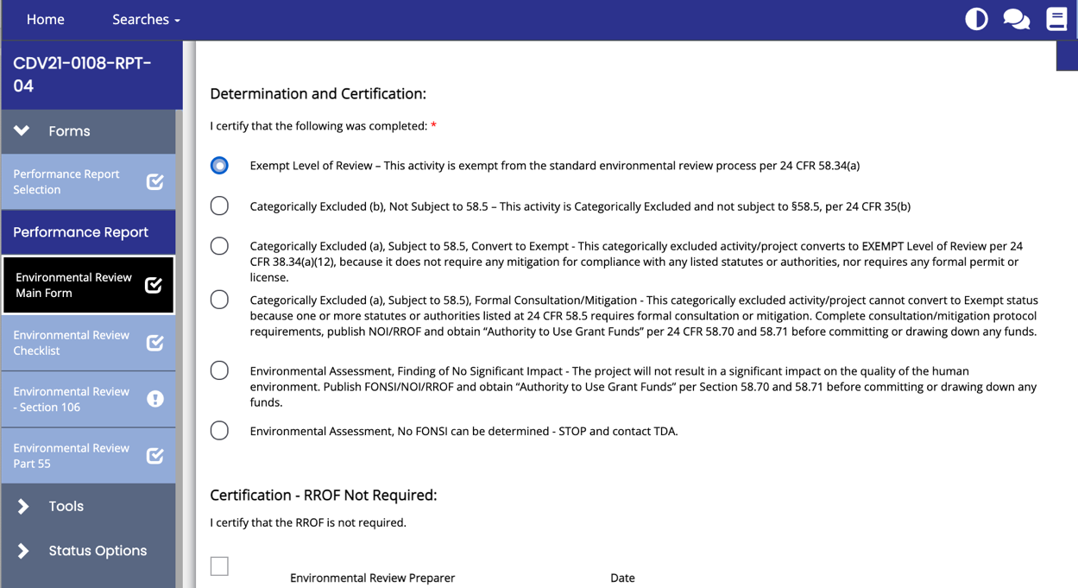

Figure 3. Environmental Review Main Form page in TDA-GO

For reviews under the categories Environmental Assessment and Categorically Excluded:

After the public comment period has expired and all comments, if any, are resolved, the Grant Recipient’s certifying officer must complete the Request for Release of Funds (RROF) and Certification (see Figure 4). See also HUD form 7015.15, found on the HUD Environmental Review webpage.
- Only the designated certifying officer may sign the RROF.
- Because the certification form certifies that the dates of the comment periods have expired, the request form must not be signed prior to the day after the end of the public comment period.
NOTE: False claims or information could lead to criminal and/or civil penalties. See 18 U.S.C. §§1001, 1010, & 1012; 31 U.S.C. §§3729 & 3802.

A Request for Release of Funds is not required for the following review categories:
- Exempt
- Categorically excluded, not subject to 24 CFR § 58.5.
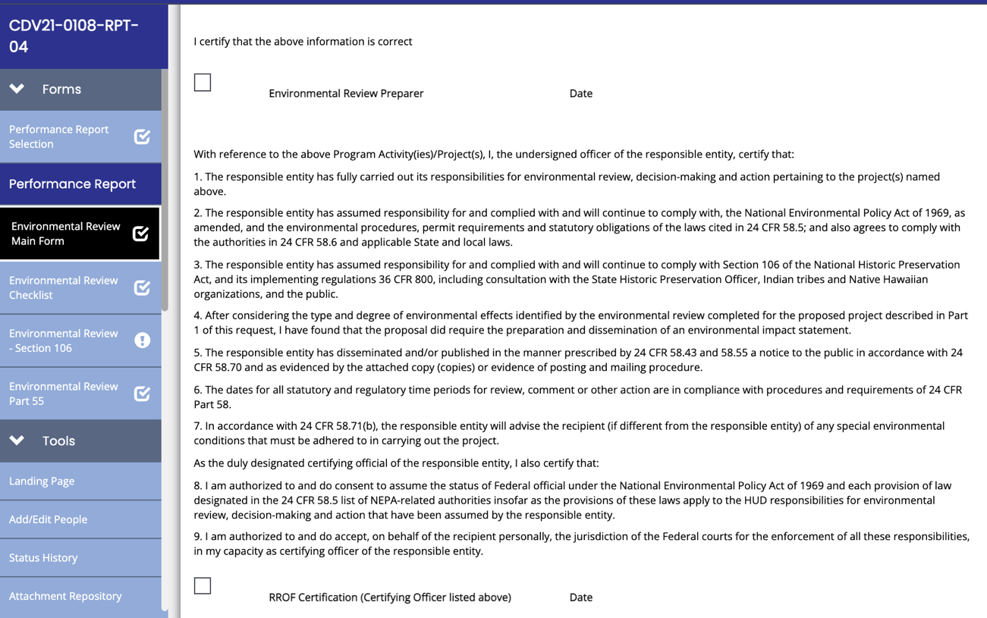

Figure 4. Certifying officer must complete the Request for Release of Funds

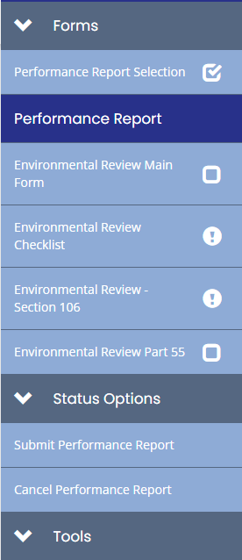
3.1.6 Step 6. Submit Clearance Documentation to TDA

The Grant Recipient must complete all required sections on the Environmental Review page in TDA-GO based on the level of review identified in Section 3.1.1 above. To obtain a release of funds, select Submit Performance Report in the Status Options section of the navigation menu.

Figure 5. Submit Performance Report

3.1.7 Step 7. State Objection Period and Release of Funds

Applicable for reviews under the categories Environmental Assessment and Categorically Excluded Subject to 24 CFR § 58.5:
- Once the Environmental Review is submitted in TDA-GO the TDA Environmental Specialist will begin the 15-day State Objection period.
- The State Objection time period is in addition to the time already allowed for public commentary as described above.
- Any person or agency may object to a certified RROF. However, the objections must meet the conditions and procedures set forth in 24 CFR Part 58, Subpart H.
- If there are no objections received after 15 days, TDA will issue an Authority to Use Grant Funds (AUGF).

Applicable for reviews under the categories Exempt Level of Review and Categorically Excluded Not Subject to 24 CFR §58.5:
- No State Objection Period is required.
- TDA will issue an AUGF following its review of the Environmental Review page in TDA-GO. The AUGF may be accessed and printed from TDA-GO for the local ERR.

The AUGF is known by many as the environmental clearance.
- Once the AUGF is issued, the Grant Recipient may commit grant funds and other funds to the project, and complete other choice limiting actions. This clearance is for the environmental condition only; other special conditions in the grant agreement must also be met before any construction funds can be released.
- The authorization is completed based on the certifying official’s signature certifying that all required procedures have been completed, along with the limited support documentation provided.

NOTE: The AUGF is not an indication that TDA has reviewed and approved the entire Environmental Review Record for the project.

3.1.8 Step 8. State’s Post-Release Review

Following the Authorization to Use Grant Funds, TDA will conduct a post-release monitoring review in accordance with 24 CFR §58.18. This review may occur at any time after the release of funds and prior to the closeout of the grant agreement. TDA may request support documentation for selected requirements or the full ERR.

If TDA determines that the Grant Recipient’s environmental review was inadequate or incorrect, the Environmental Specialist will provide technical assistance and guidance for corrections, which may include
- additional support documentation or clarification;
- a finding of non-compliance;
- a hold on grant funding until all issues are resolved;
- requirements to conduct a new Environmental Review that complies with all requirements; and/or
- disallowed costs for serious findings involving statutory or regulatory requirements that cannot be remediated.

3.1.9 Step 9. Re-Evaluation of the Environmental Determination and Subsequent Amendment/Modification Procedure

According to 24 CFR §58.47, the environmental determination must be re-evaluated any time that the Grant Recipient proposes substantial changes in the nature, magnitude, or extent of the project. The re-evaluation assists in determining whether or not the original determination and/or finding are still valid. Project amendments that may result in the need for an updated FONSI include—but are not limited to:
- Any change in project scope.
  - EXAMPLE: Adding water line improvements to a sewer line improvement project.
  - EXAMPLE: Adding sewer plant improvements to a sewer line improvement project.
- Any new project location not addressed in the original review.
  - EXAMPLE: Adding additional streets to a street reconstruction project.
  - EXAMPLE: Changing the location of a proposed water tower.
- An increase in infrastructure capacity of more than 20%.
  - EXAMPLE: Increasing a proposed water storage tank from 100,000 gallons to
150,000 gallons.
  - EXAMPLE: Adding traffic lanes to widen a street.
- A change in method or design that impacts the physical environment.
  - EXAMPLE: Adding lift stations not previously proposed to a sewer line improvement
project.
  - EXAMPLE: Adding fire hydrants to a water line improvement project where none had
been proposed.
- A change to accommodate new circumstances and/or environmental conditions that have
arisen during project implementation.
  - EXAMPLE: Addressing damage caused by a natural disaster.
  - EXAMPLE: Changing strategies from rehabilitation of a building to reconstruction or
expansion as a result of the actual building conditions.

Re-Evaluation of the Finding by the Grant Recipient
Any project changes that were addressed by the original Environmental Review will likely not require additional clearance requirements, including notices.
- The Grant Recipient should clearly document that the changes are not substantial and that the EA/FONSI or Categorical Exclusion/Exempt determination are still valid after re-evaluation. The Environmental Review Record should be updated with any new project locations, etc.
- Documentation of this reevaluation must also be recorded in the TDA-GO system Environmental Review Page. Select the form Environmental Review - Re-evaluation, located within the existing Environmental Review Report, and complete the review reevaluation questions and save the form. There is no submittal step for a re-evaluated environmental review, however TDA staff will review this page when considering any proposed amendment to the grant agreement.
- A separate letter is not required unless additional information is requested.
- See Figure 5.

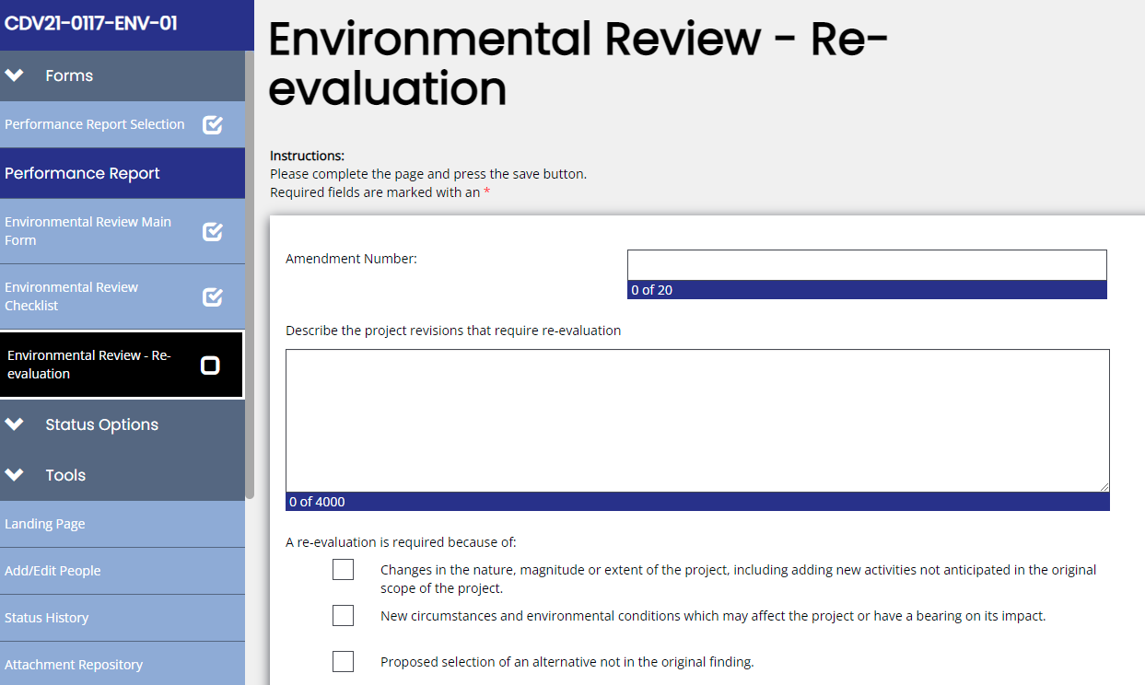

Figure 6. Environmental Review Reevaluation page in TDA-GO

If the Environmental Specialist has concerns regarding the proposed changes to the grant agreement, the Grant Recipient, TDA staff, and administrative consultant will be contacted to discuss the concerns.

If the proposed project amendment is a change in scope or activity and is not covered by the original Environmental Review, then the Entity must start at the beginning of the process, including a new Environmental Review, public notices, public comment and objection periods, and new release of funds by TDA.

TDA strongly recommends that the Grant Recipient include any anticipated alternatives (including additive alternatives) to the original project in the original Environmental Review. TDA also recommends if a construction bid is substantially less than anticipated and additional construction funds will be available, that the Grant Recipient begins the request for a grant amendment or modification as soon as possible. Thus, in the event the amendment is approved, and a new or re-evaluated environmental clearance is obtained, administrative requirements will not delay construction.

3.2 Environmental Laws and Regulations

The following provisions of law authorize state governments to assume HUD's Environmental Review responsibilities. TDA will act for HUD for Environmental Reviews, decision-making, and action that would otherwise apply to HUD under the National Environmental Policy Act (“NEPA”) and other provisions of laws that further the purposes of NEPA, as specified in 24 CFR Part 58. These regulations are referenced in 24 CFR §58.1(b).

3.2.1 Laws

The foremost environmental law is NEPA and implementing Executive Order 11514 (35 FR 4247, 3 CFR, 1966-1970 Comp., p. 902), as amended by Executive Order 11991 and the implementing regulations of the Council on Environmental Quality (40 CFR Parts 1500-1508). This is not an all-inclusive list—as projects can cross over into other laws and authorities not listed here.

NEPA
42 USC §4321 – The purposes of this Act are to declare a national policy which will encourage productive and enjoyable harmony between man and his environment; to promote efforts which will prevent or eliminate damage to the environment and biosphere and stimulate the health and welfare of man; to enrich the understanding of the ecological systems and natural resources important to the nation; and to establish a Council on Environmental Quality.

Executive Order 11514
Protection and Enhancement of Environmental Quality

Executive Order 11991
Relating to Protection and Enhancement of Environmental Quality

Historic Preservation Requirements:
- National Historic Preservation Act of 1966, 54 USC 300101 et seq.
- Archeological and Historic Data Preservation Act of 1974, 54 USC 312501-312508.
- Executive Order 11593, Protection and Enhancement of the Cultural Environment.
- Antiquities Code of Texas, Chapter 191, Texas Natural Resources Code.
- Tribal Consultation in Projects that are reviewed under 24 CFR Part 58.
- See Appendix A for web address/link.

3.2.2 Regulations

24 CFR Part 51 – Environmental Criteria and Standards
Description – These regulations provide environmental standards for determining project acceptability and necessary measures to ensure that activities assisted by HUD achieve the goal of a suitable living environment. The environmental criteria include noise abatement and control and the siting of HUD-assisted projects near hazardous operations including explosives, flammables, runway clear zones at civil airports, and accident potential zones at military airfields.

24 CFR Part 55 – Floodplain Management and Protection of Wetlands
Description – HUD regulations to implement Executive Orders 11988 and 11990 on development in floodplains and wetlands. See HUD Exchange for more information and publication requirements. This could add 15 days to the Environmental Process.

24 CFR Part 58 – Environmental Review Procedures for Entities Assuming HUD Environmental Responsibilities
Description – The procedures outlined in these regulations are used by entities that assume HUD's Environmental Review responsibilities in determining program compliance with the intent of the NEPA and other related statutes. Applicable HUD programs under these regulations include only those in which a specific statute allows governing entities to assume the Federal responsibility.

36 CFR Part 800 – Protection of Historic Properties
Description – The Advisory Commission on Historic Preservation Rules, used by HUD for all HUD projects.

