CHAPTER 10
CIVIL RIGHTS AND RELATED REQUIREMENTS

TABLE OF CONTENTS

10.1 Required Policies and Actions 2
10.1.2 Non-Discrimination – Equal Opportunity Policy 3
10.1.3 Affirmatively Furthering Fair Housing 3
10.1.4 Section 504 Accessibility Policy 5
10.1.5 Limited English Proficiency 7
10.1.6 Excessive Force Policy 9
10.1.7 Disadvantaged Businesses 10
10.1.8 Section 3 Economic Opportunities 11
10.2 Recordkeeping 17
10.2.2 Local Resolution 17
Section 10.2.3 Public Notices 18
10.3 Monitoring of Discrimination 19

CHAPTER 10
CIVIL RIGHTS AND RELATED REQUIREMENTS

All grantees of Texas Community Development Block Grant (TxCDBG) funds are required to demonstrate compliance with all state and federal requirements to ensure equal opportunity and access to all benefits derived from the TxCDBG Program.

These state and federal requirements include
- taking steps to ensure that equal opportunities are afforded to all persons and that no person shall be excluded or denied program benefits on the basis of race, color, religion, sex, national origin, age, and/or disability;
- taking steps to provide opportunities, to the greatest extent feasible, to low- and very low-income (Section 3) residents and businesses in employment, training, and contracting for construction contracts;
- taking affirmative steps to assure minority, small business, and women-owned businesses are informed of grant funded contracts;
- prohibiting the use of excessive force against individuals engaged in non-violent civil rights demonstrations;
- taking steps to Affirmatively Further Fair Housing (AFFH); and
- taking steps to assure meaningful access for persons with Limited English Proficiency (LEP).

Be diligent and consistent in implementing the project’s civil rights responsibilities and be ready to explain to local citizens the purpose and importance of the civil rights laws and requirements. Collect all handbooks, policies and procedures manuals, and resolutions or ordinances regarding equal opportunity, as well as a review of any past cases alleging discrimination against the Grant Recipient, in order to develop clear policies and procedures that effectively provide civil rights.

10.1 Required Policies and Actions

10.1.1 Citizen Participation
A critical element of the TxCDBG program is the involvement of the community in selecting grant projects and understanding its impact on the community. Grant Recipients must provide for and encourage citizen participation—especially by low- and moderately low-income persons who live in blighted or slum areas or areas served by the TxCDBG grant. See Section 104(a) (2) of the Housing and Community Development Act and 24 CFR §570.486. To participate in CDBG funding, Grant Recipients must comply with the requirements set forth in 24 CFR §570.486.
- Grant Recipients must publish a Citizen Participation Plan, including methods for encouraging citizen participation as well as complaint procedures.
- Public hearings are a required method of citizen participation for any substantial change requested to a CDBG-funded project, and after the project is complete. Reasonable advance notice of and opportunity to comment on the proposed change must be provided. See Chapter 1 for details.
- Grant Recipients must develop complaint procedures for citizens to submit complaints and grievances that include a timely written response to complaints—within 15 days where practicable. Provide citizens with the address, phone number and times for submitting complaints and grievances, and provide timely written answers to written complaints and grievances. See 24 CFR §570.486.

For a detailed discussion of citizen participation requirements, see TxCDBG Application Guide, Sample Resolution Regarding Civil Rights (Form A1014) and Sample Citizen Participation Plan (Form A1013).

10.1.2 Non-Discrimination – Equal Opportunity Policy

Grant Recipients must take actions to ensure that no person or group is denied benefits such as employment, training, housing, and contracts generated by the local CDBG activity on the basis of race, color, religion, sex, national origin, age, or disability. See Section 109 of Title I of the Housing and Community Development Act (24 CFR Part 6); the Age Discrimination Act of 1975 (42 U.S.C. 6101-6107); and Section 504 of the Rehabilitation Act of 1973 (29 U.S.C. 794). For federally-assisted construction projects greater than $10,000, contractors may not discriminate against any employee or applicant for employment because of race, color, religion, sex, sexual orientation, gender identity, or national origin. See 41 CFR §60-1.4(b) and Executive Order 13672—expanded protected groups to include sexual orientation and gender identity.

Required actions include:
- Review existing local employment policies and include the EO policy in your local government policy manual/handbook.
- Include Equal Opportunity Employer notification in employment advertisements.
- Include applicable equal opportunity provisions and certifications in the bid packets, contracts, and subcontracts. These are included in the sample bid package found in Chapter 5 Procurement. Include the EO clause required by 2 CFR 200 Appendix II in all contracts and for construction contracts > $10,000. See also 41 §CFR 60-1.4(b).
- A list of guidelines for construction contractors (including subcontractors) regarding equal opportunity is included as Sample Equal Opportunity Guidelines for Construction Contractors (Form A1001) and may be used for reference.

10.1.3 Affirmatively Furthering Fair Housing

Section 808(e) (5) of the Fair Housing Act 42 USC 3608(e) (5) requires that HUD programs and activities be administered in a manner affirmatively to further the policies of the Fair Housing Act.
The Fair Housing Act provides for the protection of the following federally protected classes:
- Race • Disability
- Color • Familial status
- Religion • National origin
- Sex

Adopt and Publicize a Fair Housing Policy
Grant Recipients must adopt (or affirm) a Fair Housing Policy by ordinance or resolution based on the requirements of the Fair Housing Act to affirmatively further fair housing choices for all seven protected classes.
- Include in the policy a plan for activities that will affirmatively further fair housing in the community.
- If the Grant Recipient is a city, pass a fair housing ordinance. If possible, include a penalty clause in the ordinance.
- If the Grant Recipient is a county, adopt written fair housing policies and procedures that are equivalent to a fair housing ordinance.
- Grant Recipients should consult with their county/city attorney or contact the applicable trade association (Texas Municipal League or Texas Association of Counties) for a sample fair housing ordinance or policy.
- Also see Sample Resolution Regarding Civil Rights (Form A1014) and Sample Fair Housing Policy Form (A1015); also see Sample Fair Housing Proclamation (Form A1007).

Grant Recipients must take at least one more action during the agreement term which publicizes the effort to affirmatively further fair housing.
- Publicize the fair housing policy through newspaper publication, fliers enclosed in utility bills, or public service announcement. See Form A1009 for a Sample Fair Housing Public Service Announcement.
- Host a fair housing booth for a local event.
- Designate April or any other month as Fair Housing Month by Proclamation or Resolution along with another sponsoring activity. Another fair housing activity must take place if this activity is chosen. See NOTE below. See Form A1007 for a Sample Fair Housing Proclamation.
- Have a written local complaint and monitoring process for the fair housing policy and notify the public of its existence through newspaper advertisements, or through notices in utility statements.

Enhanced Ideas for Meeting the Fair Housing Activities Requirement
If a Fair Housing Policy has previously been adopted by the jurisdiction, Grant Recipients may request to meet the agreement’s fair housing requirement using one of the following activities instead.
NOTE: If a grant application assigns additional points for fair housing activities, the Grant Recipient must select an activity from this list OR receive prior approval from TDA staff in order to receive those points.
- Conduct a community-wide housing analysis to determine impediments to fair housing and implement actions to eliminate these impediments.
- Sponsor or fund fair housing counseling/referral services for owners and renters.
- Promote housing opportunities outside historically minority and/or low- and moderate-income neighborhoods.
- Utilize local businesses and banking institutions (minimum of 15 organizations) to promote fair housing by displaying fair housing posters.
- Conduct free training workshops on fair housing laws to homebuyers, rental property owners, and tenant organizations.
- Sponsor a poster contest or essay writing contest at local schools to educate and promote fair housing.
- Review local zoning laws and procedures to determine whether they contribute to, or detract from, fair housing choice. Conduct a public meeting to discuss the analysis and conclusions.
- Find ways to inform builders and architects as early as possible in the project design phase, but certainly no later than the issuance of a building permit, of the need to comply with the accessibility requirements of the Fair Housing Act.

Fair Housing Activities Resource
HUD’s fair housing website (See Appendix A for link) contains a wealth of information and tools for Grant Recipients to use in conducting fair housing activities. Resources on the website include
- a fair housing planning guide
- fair housing brochures and logos
- fair housing best practices
- contact information for fair housing advocacy organizations
- accessibility guidelines for housing units

TDA recognizes that in order to conduct a fair housing activity the Grant Recipient will incur costs. The Grant Recipient may elect to pay for fair housing activities and count the expenses toward the local match requirement or submit a reimbursement request for eligible and reasonable costs to be paid by the TxCDBG grant under the General Administration line item.

Filing a Complaint Regarding Fair Housing in the State of Texas
The Texas Workforce Commission (TWC) is the entity responsible for enforcing the Fair Housing Act in the State of Texas. Complaints can also be made directly to HUD. Citizens have one year after an alleged violation to file a complaint. Complaints can be filed by email, fax, phone call, hand-delivery, or mail to
Texas Workforce Commission
Civil Rights Division
1117 Trinity Street, Room 144-T
Austin, Texas 78701
(888) 452-4778 or (512) 463-2642
TTY: 512-371-7473
Fax: 512-463-2643
Download the TWC Complaint Form – HousingComplaint@twc.state.tx.us

10.1.4 Section 504 Accessibility Policy

Section 504 of the Rehabilitation Act of 1973 prohibits discrimination in federally-assisted programs on the basis of disability. Section 504 imposes requirements to ensure that qualified individuals with disabilities have access to programs and activities that receive federal funds. Grant Recipients must adhere to the following procedures. See also 24 CFR § 8.4(a) implementing Section 504 of the Rehabilitation Act of 1973, as amended (29 USC 794).

Adoption of Grievance Procedures
Any Grant Recipient that employs 15 or more employees must adopt grievance procedures that incorporate due process standards and allow for quick and prompt resolution of complaints alleging any action prohibited by Section 504. See 24 CFR § 8.53. Grievance procedures are not required to cover applicants for employment or applicants for housing. See Form A1004 for sample grievance procedures in Section 504 Policy Against Discrimination based on Disability and Grievance Procedure.

Notices
Any Grant Recipient that employs 15 or more employees must notify all participants, applicants, and employees, including those with impaired vision or hearing, and unions, or professional organizations holding collective bargaining or professional agreements with the Grant Recipient that it does not discriminate on the basis of handicap in violation of Section 504. The notice must identify the individual designated to coordinate its Section 504 compliance (the Civil Rights Officer) and must state, where appropriate, that the Grant Recipient does not discriminate in admission or access to, or treatment or employment in, its federally assisted programs.

The notification process must ensure that all individuals, including those with visual and hearing impairments, are aware of the non-discrimination pledge.

Any recruitment or informational material published by the Grant Recipient must contain a statement regarding the Grant Recipient's pledge not to discriminate based on disability in violation of 24 CFR Part 8.

Self-Evaluation
During the contract period, all Grant Recipients are required to comply with Section 504 and must complete a self-evaluation of their Section 504 compliance and keep it on file for monitoring purposes. Grant Recipients that have completed a self-evaluation for a previous TxCDBG contract may use their previous self-evaluation forms on file to meet this requirement if all information remains accurate. During the self-evaluation process, the Grant Recipient must consult with individuals with disabilities or organizations representing them. The self-evaluation includes an examination of policies and practices relative to the Section 504 regulations. Any policies and practices that do not meet the Section 504 requirements must be modified, and corrective action taken to remedy any discrimination found. See 24 CFR §8.51. A sample Section 504 Self-Evaluation Form is included with Form A1006.

Communication
Grant Recipients should furnish appropriate auxiliary aids where necessary to allow an individual with disabilities an equal opportunity to participate in all CDBG program activities. Grant Recipients should implement procedures that allow individuals with disabilities to obtain information concerning the existence and location of accessible services, activities and facilities. Such procedures must ensure, to the maximum extent possible, that individuals with disabilities receive the benefits and services of the program or activity receiving CDBG assistance.

Examples of auxiliary aids include telecommunication devices for the deaf (TDD), Text Telephone (TTY), the Texas Relay System (where a TDD is not feasible), audio visual presentations, qualified sign language and oral interpreters, readers, or the use of taped and Braille materials, interpreters, large-lettered notices, and posting notices at a level readable by individuals in wheelchairs.

Accessible Facilities
For all publicly-funded construction, renovation, or modification to buildings or facilities—as defined in Texas Administrative Code Title 16, Part 4, § 68.10 in which construction is expected to cost $50,000 or more—Grant Recipients are required to submit plans and specifications to the Texas Department of Licensing and Regulation (TDLR) for review and approval. See Texas Government Code, Chapter 469, Section 469.101. TDLR is responsible for ensuring that all plans and specifications meet accessibility requirements in accordance with the elimination of architectural barriers provisions of Chapter 469 of the Texas Government Code. TDLR regulations further require inspection of completed construction of applicable buildings or facilities to ensure compliance with Texas Accessibility Standards. The TDLR clearance requirements are included in the special conditions of all TxCDBG contracts that include public facilities.

Employment
Grant Recipients should not use any practices that unreasonably limit employment opportunities for individuals with disabilities. Grant Recipients must also reasonably accommodate the known needs of employees and applicants with special needs. Examples include retrofitting workstations to accommodate wheelchairs and providing special computers for hearing and sight challenged workers.

10.1.5 Limited English Proficiency

Each Grant Recipient must take reasonable steps to provide meaningful access to federally-funded programs (grants) for all persons with Limited English Proficiency (LEP). Grant Recipients must establish and adopt a plan for each grant project, determining if there is a need for LEP services within the community and, if applicable, how appropriate language assistance will be given.

LEP persons are individuals who do not speak English as their primary language and who have a limited ability to read, write, speak, or understand English. Grant Recipients are encouraged to review HUD’s Frequently Asked Questions (FAQ) website to understand the expectations and purpose of LEP when evaluating the appropriate provisions for a TxCDBG project.

Identifying requirements for providing LEP services requires a four-factor analysis:
- The number or proportion of LEP persons served or encountered in the eligible service population. Served or encountered includes those persons who would be served or encountered by the recipient if the persons received adequate education and outreach and the recipient provided sufficient language services;
- The frequency with which LEP persons come into contact with the program;
- The nature and importance of the program, activity, or service provided by the program; and
- The resources available and costs to the recipient.

Safe harbor guidance—which identifies actions that will be considered strong evidence of compliance—for the first factor is published by the U.S. Department of Justice and uses the Census Bureau data found at https://data.census.gov/.
- Search for Table B16001 (or S1601) language spoken at home, select the most recent 5-year estimate data, and identify the appropriate geography. Review the number or percent of speaks English less than very well under the subcategories of Spanish, other Indo-European languages, and other languages. If necessary, a more detailed breakdown of languages spoken can be found in related census tables, such as B16002.
- As a general rule, if the size of the language group is more than 5% of the eligible population or beneficiaries and has more than 50 in number, or if the language group has more than 1,000 individuals in the eligible population in the market area or among current beneficiaries, then vital documents must be translated.
- Language groups should not be aggregated together. If https://data.census.gov/ indicates that less than 5% of the community population speaks English less than very well, the Grant Recipient must use its knowledge of the project beneficiaries to determine whether language assistance may still be needed.
- In addition, consider whether the project is located in an area of the community that is more likely to include LEP residents than the jurisdiction overall – if so, services must be provided.

Once the required services are identified, the Grant Recipient must identify the vital documents covered by the LEP plan. Vital documents are those documents that ensure that an eligible LEP person can meaningfully have access to the CDBG project. Thus, vital documents include Citizen Participation notices (complaint procedures, hearings notices, civil rights notices), environmental notices, outreach notices and application materials for housing rehabilitation or on-site sewer facility assistance, and any other published notice that may allow an eligible person with limited English proficiency to participate in discussing proposed CDBG activities.
- If a document is required by the LEP policy to be translated, the full text translation must be made available.
- BEST PRACTICE: Publish or post the full text of the translated document alongside the English language version.
- In certain cases, the Grant Recipient may publish the full text of the English language document along with a translated summary of the document’s contents and contact information for obtaining the full text. This option is available ONLY if Table B16001 (or S1601) identifies less than 10% of residents as “speaks English less than very well” AND the LEP plan does not identify additional LEP needs based on the project’s location. Example La ciudad de [Sample] ha realizado una revisión ambiental para el proyecto de construcción de la línea de agua en Main Street, financiado por el Programa de Subvenciones en Bloque para el Desarrollo Comunitario de Texas. Para revisar una traducción completa de este aviso en español, comuníquese con [Nombre] al [teléfono] o [correo electrónico].
- A reference to translation availability without also summarizing the content of the document is not sufficient for effective communication with LEP persons.

Limited English Proficiency (LEP) Plans are grant/project specific and therefore apply only to the particular grant and period.

The LEP plan is documented as part of the Group A Performance Report in TDA-GO.

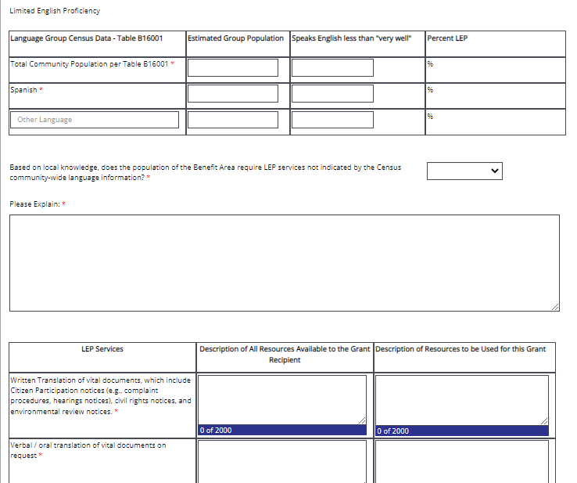
Figure 1. LEP plan in TDA-GO

10.1.6 Excessive Force Policy

In accordance with Section 104(l) of the Housing and Community Development Act, as amended, Grant Recipients receiving TxCDBG funding must adopt an Excessive Force Policy that prohibits the use of excessive force against non-violent civil rights demonstrations. See also state’s certification requirements at 24 CFR § 91.325(b)(6).

When Grant Recipients sign their agreement(s) they certify that they will pass and enforce the following policies:
- A policy prohibiting the use of excessive force by law enforcement agencies within its jurisdiction against any individuals engaged in non-violent civil rights demonstrations; and/or
- A policy of enforcing applicable state and local laws against physically barring the entrance to, or exit from, a facility or location that is the subject of such non-violent civil rights demonstrations within its jurisdiction.

See Sample Excessive Force Policy (Form A1003).

10.1.7 Disadvantaged Businesses

Grant Recipients must affirmatively take necessary steps to utilize small (SBE), minority-owned (MBE) and women-owned businesses (WBE). Although Grant Recipients are not directly responsible for meeting a specific minority business participation goal, TDA reports to HUD on the levels of MBE and WBE hiring under all TxCDBG contracts. See 2 CFR §200.321.

The following suggestions can be used to increase participation of small, minority- and women-owned businesses.
- Place qualified small, minority, and women-owned firms on solicitation lists. The Texas Comptroller of Public Accounts provides the Historically Underutilized Business (HUB) Directory that includes small businesses that are minority and women-owned. The directory and other information on HUB certification is available on the Texas Comptroller’s website.
- Utilize the Minority Business Development Centers (MBDCs) located throughout Texas. The Minority Business Development Agency of the U.S. Department of Commerce funds MBDCs. This network can assist in achieving local and state minority business goals by providing relevant information, management assistance, technical assistance, program outreach, and brokerage services to minority firms. A listing of MBDCs can be found on the internet at http://www.mbda.gov.
- Solicit bids/services from small, minority, and women-owned businesses when issuing requests for proposals (RFPs), requests for qualifications (RFQs), and soliciting construction bids.
- Divide project activities into smaller tasks or services to allow participation by these types of businesses, if economically feasible. Discuss with TxCDBG staff to avoid violation of program rules with respect to small purchase procurement and awards to best, most responsible bid.
- Provide direct bonding assistance to minority business enterprises in order to promote their participation in the CDBG funded projects. NOTE: Payment of bond premiums on behalf of such firms is an allowable expenditure that can be paid for with CDBG funds only out of the general administration budget category.
- Provide small, minority and women-owned businesses with information regarding the Small Business Administration (SBA) Surety Bond Guarantee Program. This program opens the bonding system to new, small, or financially marginal disadvantaged construction contractors who are not able to obtain bonding through their own efforts or find it too costly in the standard market. Information on the program and local contact information can be found on the SBA website.

In order to meet federal reporting requirement, the Grant Recipient must provide data regarding the ownership of each vendor / service provider on the TDA-GO Materials and Services Report. See also Chapter 5.

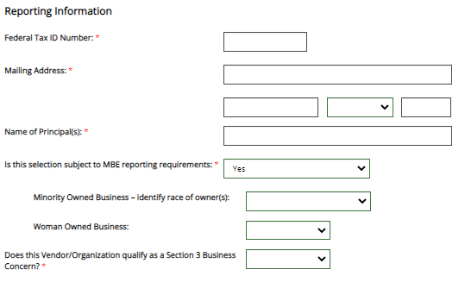
Figure 2. Materials and Services Report in TDA-GO

10.1.8 Section 3 Economic Opportunities

Section 3 of the Housing and Urban Development Act of 1968 requires that, to the greatest extent feasible, economic opportunity generated by CDBG funds and other HUD assistance, most importantly employment, is directed to low- and very low-income persons, particularly those who are recipients of government assistance for housing, as well as residents of the community in which the federal funds are spent.

HUD established benchmarks for Section 3 goals and expects the TxCDBG program to cumulatively report 25% of the total labor hours for grant-assisted projects each year as performed by Section 3 Workers; the HUD benchmark for Targeted Section 3 Workers is 5% of total labor hours worked. Failure to achieve these benchmarks requires additional justification by the state, which may necessitate additional information from Grant Recipients.

HUD’s regulations for implementing Section 3 mandates can be found at 24 CFR Part 75. These administrative rules establish the requirements to be followed to ensure the objectives of Section 3 are met. Federal rules do not require Grant Recipients to contract or subcontract with a Section 3 business concern, nor do the rules require hiring of Section 3 workers. However, Grant Recipients must be able to demonstrate that, where possible, contracting, employment, and training opportunities were made available to workers and businesses meeting Section 3 designation criteria.

Applicability
Section 3 requirements apply to all TxCDBG grants unless otherwise identified by this Implementation Manual or the Grant Agreement.
- The requirements apply to the entire project that is funded with Section 3 covered financial assistance, regardless of whether the Section 3 project is fully- or partially-funded with CDBG assistance.
- All construction and administrative services contracts must comply with the programmatic requirements below.
- All work performed by employees of the Grant Recipient and its partners, regardless of whether force account cost reimbursement is requested, must comply with the programmatic requirements below.
- Section 3 goals and data reporting requirements generally do not apply to contracts for materials, planning, and professional services. Professional services include non-construction services that require an advanced degree or professional licensing (e.g., engineering, architecture, land surveying, accounting).

Section 3 Compliance
Grant Recipients must complete each of the following steps in order to be considered compliant with Section 3 programmatic requirements. Key terms for these steps are described in the following sections:

Step 1. Identify the Section 3 Service Area. A map of the Section 3 service area must be submitted to TDA, as part of the Group A requirements described in Chapter 1.

A Section 3 Service Area for a TxCDBG project is determined as follows:
- Identify the project site. For infrastructure projects, the project site is the area included in the Environmental Review project description. The center point of this project site is the basis for the Section 3 Service Area.
- Identify a circle with a one-mile radius, with the project site central point as the origin.
- Calculate the population that resides within the one-mile circle. If less than 5,000 people according to the most recent U.S. Census, then aggregate census block group geographies totaling a minimum of 5,000 persons that both
    - surrounds all components of a Project Site, AND
    - most closely approximates a circle shape.
The Service Area map must include:
- Grant Recipient name and contract number;
- the project center point;
- a circle around that center point that is 1 mile circumference;
- if the population within the 1 mile circle is less than 5,000 persons –
  - labeled block group areas surrounding the center point that are being claimed for the service area;
  - a table or other documentation showing the census population in each of the block groups on the map, and the sum of those populations;
- If the population within the 1 mile circle is greater than or equal to 5,000 persons –
  - statement describing how this population was determined;
  - if applicable – labeled block groups and population data used to inform the Grant Recipient’s determination that the population exceed the threshold.

For examples, see Sample Section 3 Service Area (Form A1021). TDA has discretion to determine whether the geographies identified by the subrecipient are the appropriate Service Area, and to require revision if necessary.

Step 2. Facilitate Contracting Opportunities for Section 3 Businesses. Prior to procuring or selecting any contract for construction services, the contracting opportunity must be reported to the resources below, in addition to any public advertisements required by Chapter 5 Procurement. The opportunity may be reported to these resources by any interested party. Retain a screen shot of each resource demonstrating that the data was provided at least ten business days prior to the bid opening date for each opportunity unless otherwise directed by TDA staff:
  - HUD’s Section 3 Opportunity Portal: https://hudapps.hud.gov/OpportunityPortal/search.action–
    - Recipient Tax ID:746027560
    - Recipient Agency: Texas Department of Agriculture
    - Recipient Agency Location: Texas

  - At least one organization providing access to and assistance with bid opportunities, particularly those that recognize small and disadvantaged businesses that are likely to include Section 3 Businesses, such as:
    - Public/non-profit organizations;
    - Private plan rooms; or
    - Local Workforce Solutions Offices (WIOA One Stop Shop), if applicable. See https://www.twc.texas.gov/directory-workforce-solutions-offices-services;

  - TDA-GO! Materials and Services Record Pre-Selection Clearance data including bid opening date.

NOTE: TDA will ensure that Section 3 Businesses are included in the pre-qualified grant administrator application process, therefore, this step is not required for administration services.
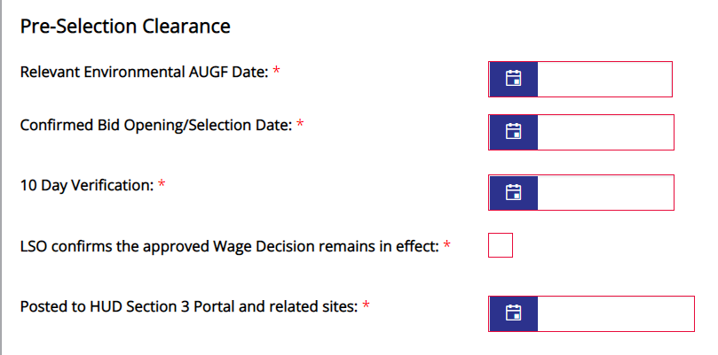
Figure 3. Pre-Selection Clearance in TDA-GO

Step 3. Facilitate General Employment Opportunity Information for Section 3 Workers. In an open meeting of the local governing body, the Grant Recipient must present the Section 3 goals of the CDBG program. This item must be reflected in the agenda and/or minutes of the meeting. TDA recommends completing this step at the meeting prior to the first publication for a construction bid process; however, in all cases it must be completed prior to requesting grant funds to reimburse construction costs. See Chapter 1, Group B requirements. The presentation must include
  - HUD’s Section 3 Opportunity Portal - https://hudapps.hud.gov/OpportunityPortal/search.action
  - Texas Workforce Solutions - WorkInTexas.com and
  - other Section 3 information as described in the Section 3 Sample Presentation to Local Community (Form A1024).

Step 4. Facilitate Specific Employment Opportunities for Section 3 Workers. If new employees are needed OR if vacancies exist for work on the TxCDBG-assisted project, the Grant Recipient and/or contractor must access the following resources to identify potential Section 3 employees—a printout of the results of the portal search in the local files is acceptable documentation of this effort. Grant Recipients and contractors are not required to employ Section 3 workers, nor to modify the qualifications or requirements of the position, but must demonstrate an effort to identify potential employees as appropriate, including documentation for any applicants that are Section 3 Workers.
  - HUD’s Section 3 Opportunity Portal - https://hudapps.hud.gov/OpportunityPortal/search.action;
  - Texas Workforce Solutions - WorkInTexas.com; and
  - Local Workforce Solutions Office (WIOA One Stop Shop), if applicable - https://www.twc.texas.gov/directory-workforce-solutions-offices-services.

Step 5. Ensure Contractor Compliance.
  - Include the required contract provision in all applicable contracting opportunities. See Appendices D and F.
  - Collect records for all construction and administration service providers, including subcontractors, documenting the labor hours performed by each employee and the Section 3 status of each employee. Generally, this consists of payroll records and certification of status for each employee. A summary of this information must be reported to TDA as part of the Project Completion Report, and support documentation must be maintained in the local files.

Step 6. Additional Efforts. Record all additional efforts to ensure Section 3 Businesses have opportunity to compete for contracting opportunities, and that Section 3 Workers and Targeted Section 3 Workers have the opportunity to benefit from the TxCDBG assistance. These efforts support the state’s explanation, should the program not meet the established benchmarks, and identify areas where the TxCDBG program could support Section 3 Business and Workers in the future. Examples include
  - outreach efforts
  - training or apprenticeship opportunities
  - technical assistance to Section 3 workers (multiple types)
  - technical assistance to Section 3 business concerns
  - job fairs
  - divide contracts into smaller jobs
  - bonding assistance
  - other business registries

Key Definitions
In order to meet the Section 3 reporting requirements, all workers for the project must be classified as one of three worker categories. Report the most restrictive category that is appropriate for an individual worker:
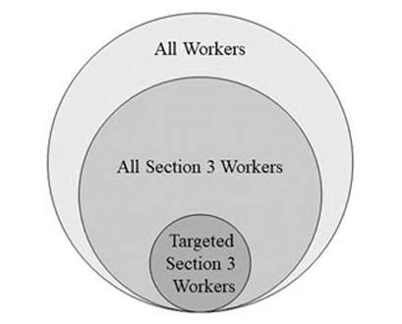
Criteria for All Worker Designation
All individuals performing applicable work (labor hours) for the TxCDBG-funded project that do not meet one of the Section 3 designations are reported only under the All Workers category.

Criteria for Section 3 Worker Designation
To comply with Section 3 Reporting requirements, the Grant Recipient must determine whether each individual performing construction or administrative work on the project meets the criteria for a Section 3 Worker. A Section 3 Worker is any worker who currently, or when hired by the current employer within the past five years, fits at least one of the following categories:
- The worker’s individual income for the previous or annualized calendar year is below the income limit for a family size of one published on TDA’s website for use in income surveys. Income limits are based on the county in which the employee resides. NOTE: information regarding family size or income from other family members is not required.
- The worker is employed by a Section 3 business concern.
- The worker is a YouthBuild participant.

Each Section 3 worker’s status must be documented with one of the following:
- A worker’s self-certification that their income should be less than or equal to the HUD limit using the TxCDBG Income Survey Questionnaire, clearly marked in the place field as “Section 3 Income Only”;
- A worker’s self-certification of participation in a means-tested program such as public housing or Section 8-assisted housing;
- Certification from a public housing authority (PHA), or the owner or property manager of project-based Section 8-assisted housing, or the administrator of tenant-based Section 8-assisted housing that the worker is a participant in one of their programs;
- Section 3 Status Summary Certification Form (Form A1022), certifying that each listed worker’s income from that employer is at or below the income limit. This certification is based on a calculation of what the worker’s wage rate would be if annualized on a full-time basis;
- Section 3 Status Summary Certification Form (Form A1022), if the employer is a Section 3 business, identifying all workers for the project; or
- An employer-generated document that includes the worker name and assignment of Section 3 status based on the employer’s review of the annualized income of the worker, and is signed by the employer.

Criteria for Targeted Section 3 Worker Designation
The targeted Section 3 worker reflects both statutory and policy priorities to direct employment and economic opportunities to low- and very low-income individuals.

For CDBG, the definition of a Targeted Section 3 Worker is a Section 3 worker that is
- employed by a Section 3 business (see Section 3 Business definition above); or
- a worker who currently fits or when hired fit at least one of the following categories, as documented within the past five years:
  - Living within the service area of the project; or
  - A YouthBuild participant.

If reporting Targeted Section 3 workers, mark the location of each targeted Section 3 worker’s residence on the Service Area map. Employers must maintain the current address for each employee and must provide this information upon request by TDA or other authorized agencies, while safeguarding as sensitive information.

Criteria for Section 3 Business Designation
One way to target grant funding to the workers that are described in HUD’s Section 3 goals is to identify Section 3 businesses. Section 3 businesses must meet at least one of the following regulatory criteria, documented within the last six-month period:
- It is at least 51% owned and controlled by low- or very low-income persons;
- Over 75% of the labor hours performed for the business over the previous three-month period are performed by Section 3 workers; or
- It is a business at least 51% owned and controlled by current public housing residents or residents who currently live in Section 8-assisted housing.

To register as a Section 3 Business, provide the required information for the HUD Section 3 Business registry at HUD Section 3 Business Registry.

Section 3 Business status will be reported once for each contract for services. Once a business is determined to be a Section 3 Business, the designation will remain in effect for the life of the contract for services. Records supporting this status must be made available upon request to TDA, HUD, or other state or federal authorized officials. Please redact Personally Identifiable Information (PII) from payroll records prior to releasing any documentation under this requirement. For construction contractor certified payroll reports, HUD requires first payroll on which each employee appears to include the employee's name and an individually identifying number. Afterward, the identifying number does not need to be reported unless it is necessary to distinguish between employees.

NOTE: Section 3 Businesses may only be selected in accordance with the procurement standards of Chapter 5—including price, ability, and willingness to comply with program requirements, to be considered lowest responsible bidders on contracting opportunities being sought. However, Grant Recipients should make every effort to ensure that Section 3 Businesses are able to effectively participate in the opportunity. In turn, contractors and others should direct their efforts to award subcontracting opportunities generated from the expenditure of housing and community development financial assistance to Section 3 Businesses.

10.2 Recordkeeping

10.2.1 Civil Rights Officer
The Grant Recipient must designate a Civil Rights Officer (CRO). The CRO will be responsible for ensuring all requirements in this chapter are met and all documentation related to compliance with this chapter’s requirements is submitted to TDA.
- The CRO serves as the Grant Recipient’s Section 504 Coordinator, Equal Opportunity Officer, and Fair Housing Officer.
- Grant Recipients are the ultimate responsible entity for the enforcement of the Civil Rights Requirements. Therefore, the CRO must be a local staff member or official.
- Prior to submitting the first payment request, the authorized official must provide the name of the designated CRO. This information is entered on the grant overview page of the TDA-GO application/grant document and requires the authorized official’s certification.
- BEST PRACTICES: Upon the award of any TxCDBG grant, discuss all required civil rights, equal opportunity, and citizen participation policies and plans during a city council or commissioner’s court meeting to ensure that both local leadership and residents understand the policies and plans.
- The Civil Rights Responsibilities Checklist (Form A1016) provides a guide for civil rights requirements.

10.2.2 Local Resolution

To demonstrate compliance with the requirements of this chapter, Grant Recipients must adopt a resolution through the local governing body (city council/commissioners court) to adopt and/or reaffirm the following required community policies. These policies may have already been adopted previously.
- Citizen Participation Plan and Grievance Procedures (Form A1013);
- Section 504 Policy and Grievance Procedures [If Grant Recipient employs 15 or more employees], (Form A1004);
- Fair Housing Policy (Exhibit 1015);
- Excessive Force Policy (Form A1003); and
- Code of Conduct (Form A1002).

In addition, the resolution identifies the Grant Recipient’s commitment to the following requirements:
- Section 3 economic opportunity;
- Limited English proficiency; and
- Affirmatively furthering fair housing activity.

The local resolution submitted for each TxCDBG grant must:
- contain language to adopt any civil rights requirements not currently in effect;
- contain language re-affirming each required civil rights policy previously adopted remains in effect; and
- be approved by the local governing body on or after the date the Request for Applications was released, and prior to submittal of the TDA-GO Group A performance report.
- A sample of this resolution can be found as Form A1014 - please revise the sample language to either "adopt" or "reaffirm" policies as appropriate.

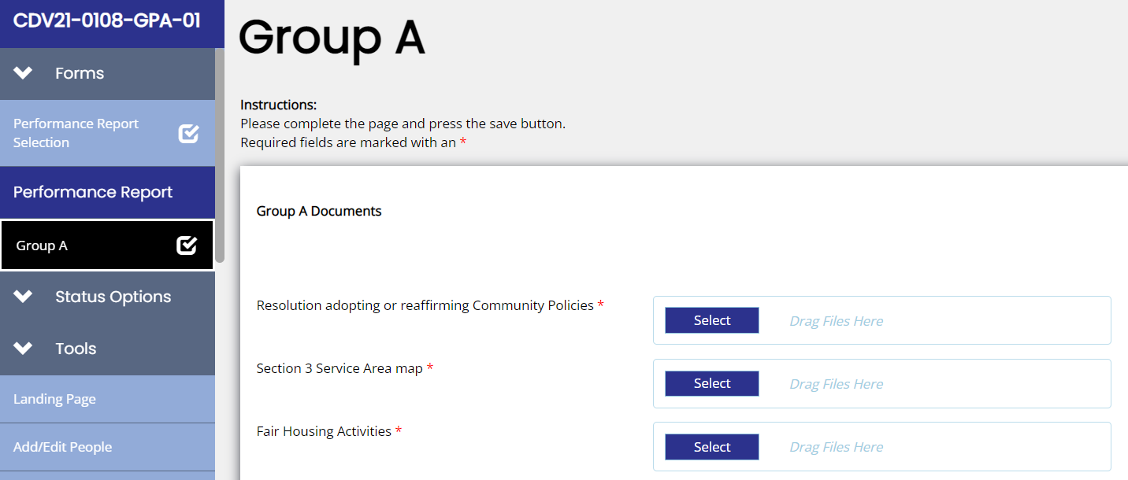
Figure 4. Group A documents in TDA-GO

Copies of the four policies addressed by the resolution must be provided. Upload the documents to the Grant Recipient’s profile to avoid the need to resubmit these policies with each grant received. To upload, select your name, select Profile, and navigate to the Organization Details page.
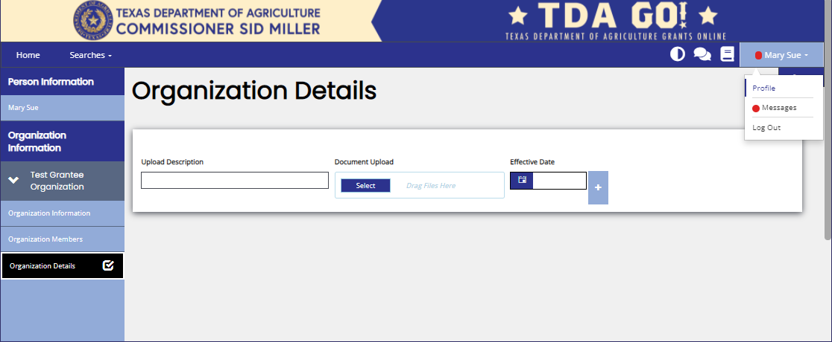
Figure 5. Organization Details in TDA-GO

Section 10.2.3 Public Notices

The notices required by this chapter must be published and/or posted as required by Chapter 1, Administrative Requirements.

BEST PRACTICE: Post the required notice to the Grant Recipient’s website, including full text (or links to full text) located on a page accessed regularly by local residents. Posted notices should remain available to the public throughout the life of the grant agreement, and at a minimum must be posted for 60 days. Screenshots of the webpage posting that clearly display the date and time of the image, along with a signed Affidavit of Posting (Form A100), may be accepted as documentation of compliance.

Newspaper notices must be published no more than two years prior to the grant agreement start date, and no later than the grant agreement end date. This means that published notices could be used for multiple TxCDBG projects with grant periods that occur consecutively.

10.3 Monitoring of Discrimination

If there has been a determination of discrimination against a Grant Recipient, the Grant Recipient must develop a plan that identifies the effects of past discrimination and specifies actions to overcome the identified effects. A determination of discrimination can be a result of
- a compliance review conducted by HUD or by TDA.
- a discrimination complaint investigation carried out by the HUD Regional Fair Housing and Equal Opportunity Office (FHEO); or
- an employment discrimination complaint investigation conducted by the Equal Employment Opportunity Commission.

TDA encourages the Grant Recipient to take affirmative action to address self-identified instances of possible discrimination that is indicative of past discrimination. EXAMPLE: If Grant Recipient employment is not representative of the general population of the jurisdiction, Grant Recipients are encouraged to design a program to affirmatively increase employment, training, and promotion opportunities for members of the affected groups.

NOTE: Complaints of employment discrimination should be referred to the Texas Workforce Commission, Civil Rights Division. See Appendix A for link to Equal Employment Opportunity Commission.

