INTRODUCTION

The goal of the Texas Community Development Block Grant (TxCDBG) program is to develop viable communities by providing decent housing and a suitable living environment, as well as by expanding economic opportunities—principally for persons of low-to-moderate income.

Eligible applicants are non-entitlement cities under 50,000 in population and non-entitlement counties that have a non-metropolitan population under 200,000 and are not eligible for direct CDBG funding from HUD may apply for funding through any of the Texas CDBG programs.

In awarding funding pursuant to Government Code Section 487.351(c), the Texas Department of Agriculture (TDA) shall give priority to eligible activities in the areas of economic development, community development, rural health, and rural housing to support workforce development.

The objectives of the TxCDBG program are to
- improve public facilities to meet basic human needs, principally for low-to-moderate income persons;
- improve housing conditions, principally for persons of low-to-moderate income;
- expand economic opportunities by creating or retaining jobs, principally for low-to-moderate income persons; and
- provide assistance and public facilities to eliminate conditions hazardous to the public health and of an emergency nature.

Prior to 2021

Prior to 2021, all TxCDBG Grant Applicants were required to apply for Community Development Block Grant (CDBG) funds using over 100 different paper forms, checklists, reports, and applications— all of which were emailed and/or snail-mailed to TDA staff.

Welcome TDA-GO

The TxCDBG staff is proud to announce TDA-GO! This interactive, online application system has been designed with the Grant Applicant / Grant Recipient in mind—easy-to-navigate and easily updated. TDA-GO will store all necessary forms for your grant application in one place, and be accessible from a computer through a unique log-in for each user.

Steps to Get Started in TDA-GO
- The initial Registration for your organization must be completed by an Authorized Official (AO) for the organization. Click here (https://tda-go.intelligrants.com) to get started.
- Once the AO registers the organization, they will receive an email Notification of Access Approval from the online systems administrator.
- The AO can then designate access to your organizational account for additional staff members as they deem appropriate.
- To visit the TxCDBG website click here. (https://www.texasagriculture.gov/GrantsServices/RuralEconomicDevelopment/RuralCommunityDevelopmentBlockGrant(CDBG).aspx)

Key TDA-GO Roles
- Each TDA-GO participant will be assigned one or more of the following roles.
- It is the responsibility of the Grant Recipient to ensure that each person is assigned appropriate roles.

Authorized Official | Person authorized by resolution as signatory for grant agreements and payment requests
Project Director | Local official or employee of Grant Recipient designated to prepare and submit grant related documents in TDA-GO; must be certified as TxCDBG Certified Administrators to take action once the grant agreement is executed
Payment Processor | Local official or employee of Grant Recipient authorized to prepare and submit payment request documentation only
Consultant | Third party staff authorized through procured contract or other agreement to prepare and submit grant related documents in TDA-GO; must be certified as TxCDBG Certified Administrators to take action once the grant agreement is executed
Agency Viewer | Local official or employee of the Organization that is granted view only access to applications in the TDA-GO system

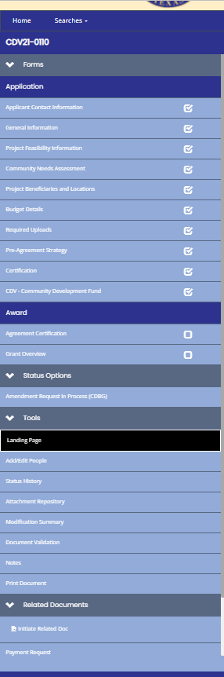
Key TDA-GO Functions

Navigating the Document

The TDA-GO grant document, referred to in the system as the Application for the entire project, is navigated using the navigation menu that appears on the left side of every TDA-GO page. The menu includes several major sections, with headings shown as dark blue bars:

- Application – Forms originally completed by the Grant Recipient when applying for grant funding.

- Award – Includes the grant agreement and other project information that may be updated throughout the agreement period.

- Status Options – See discussion below.

- Tools – Includes tools for managing access to and recording action history for the grant document .

- Related Documents – Subdocuments that are related to the grant agreement and submitted for TDA action, including Payment Requests and Performance Reports.

Saving the Page
Throughout the life of the project, the Grant Recipient will provide information, including reporting data and documents, to TDA through the TDA-GO system. System roles with permission to complete these entries will have a Save button in the top right corner of the page.
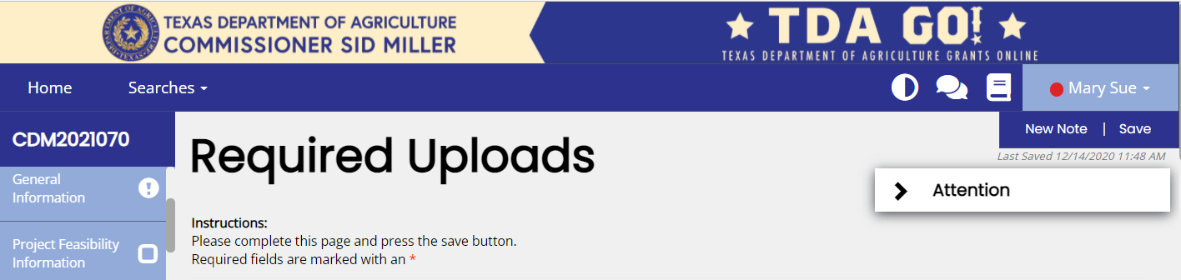

Figure 1. Noting the Save button in the top right corner of the page

NOTE: Certain pages are restricted so that only TxCDBG Certified Administrators (assigned Project Director or Consultant roles) will have permissions to Save the page. Other pages and/or fields are limited to Authorized Officials.

Changing Status
Reports and requests are submitted in TDA-GO by changing the status of the TDA-GO form. The status options available vary based on the current status of the grant and role of the individual user. Changing the status of a document means updating the role responsible for the next step in the approval process; the previous role may no longer have save permissions once the status is updated.

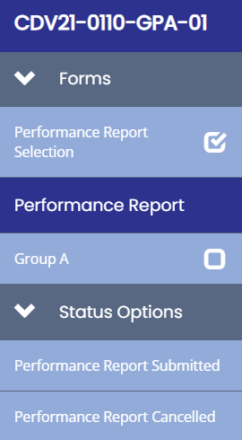
Identify the current status by hovering over the application number.

Find the available status options by scrolling down the blue navigation menu. Select the appropriate menu option for the action you wish to take.

Figure 2. Hover over the application number
for the current status
Figure 3. Status options

