TxCDBG Closeouts for Migrated Grants

Use Grant Overview Reports to prepare for Closeout
The reports located at the bottom of the Grant Overview page of the Application/Grant mirror those the Authorized Official will certify during the closeout process. Be sure to access these reports early to ensure complete and accurate information is reported.
- For migrated grants, the reports marked below will provide limited meaningful information; if no data is reported, the report will not generate and may redirect to another page.
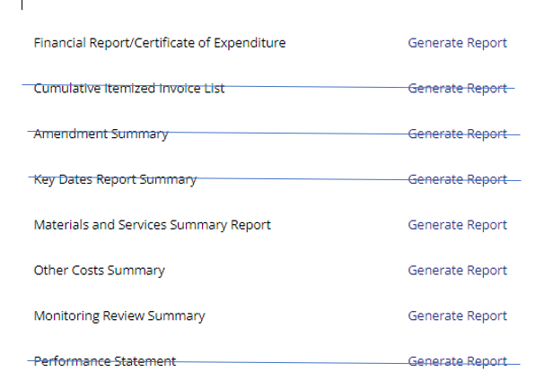

Verify all costs are eligible
Eligible costs must be reported in one of two locations in TDA-GO:
- Materials and Services Report (MSR), or
- Grant Overview page - Eligible Costs not Reported on MSR section
Confirm that all MSRs are in MSR Contract Complete Status.
- Create a new form for any missing prime contractors/vendors.
- Confirm the final contract amount and cost distribution are accurate for each MSR – submit a change order if appropriate.
- Status Change the MSR - click “Begin MSR Completion Report”
  - Complete the Final Wage Compliance (if applicable) and Work Completed pages
  - For construction contracts, generate and upload COCC (Form A709 will be accepted only if signed prior to the migration date, July 7, 2022)
- Status Change the MSR – click “MSR Contract Completion Submitted.”

Create final Payment Request
The closeout process requires one payment to be marked as “Final” within the system
- Confirm all pre-TDA-GO expenditures are accurately reflected on the most recent Payment Request Summary page.
- Create a new Payment Request.
  - Mark the Payment Request as Final = Yes
  - Enter any remaining eligible costs, including final administration costs.
  - Enter all match expenses, which were not identified in the migration. If previously submitted, indicate this in the Invoice Notes.
  - If insufficient matching funds have been expended, contact your Grant Specialist for assistance re-allocating costs between grant and match fund types.
- Status Change the Payment Request – click “Submit”

Check for other required documents
- All Performance Reports (Environmental Review, Acquisition, Group A and Group B) must be in “Performance Report Approved” status.
- A final Monitoring Review must be created before beginning closeout – if none is found under the Related Documents menu, submit a Support Ticket.

Begin Grant Closeout
- Status Change the Application/Grant – click “Begin Closeout”
  - Complete the Project Completion Report page.
  - Check each box to certify the information is accurate and complete.
  - For migrated grants, attach as Additional Documentation a copy of the most recent Performance Statement Exhibit A executed prior to the TDA-GO migration.
  - Save the page – if the grant includes direct beneficiaries (14A households or 18A jobs), a new page will appear to report the required information.
  - Obtain the electronic signature of the Authorized Official - check the certification box and save the page.
- Status Change the Application/Grant – click “Submit Closeout”

